|  |  |
| --- | --- |
| Leasing and Integrated Accounting System | Software Requirement Specification |
| **Version: 2.0**  **Owner: Ethics Advanced Technology Limited**  **Date:08/11/2014** | |

Revision History

|  |  |  |  |
| --- | --- | --- | --- |
| Doc. Ver. | Date | Author | Description of Revision |
| V 1.0 | 01/11/2014 | EATL | SRS V.1 |
| V 2.0 | 08/11/2014 | EATL | SRS V.2 |
|  |  |  |  |
|  |  |  |  |

Contents

1. Introduction 4

1.1 Purpose 4

1.2 Scope 4

1.3 Audience Description 4

1.4 References 4

1.5 Definitions, Acronyms, and Abbreviations 4

2. Overall Description 5

2.1 Overview 5

2.2 Target platform 5

3. Functional Requirements 5

3.1 Overview 5

3.2 Feature/Function 1 5

3.3 Feature/Function 2 6

3.4 Feature/Function 3 6

3.5 Feature/Function 4 7

4. Non-Functional Requirements 7

4.1 Performance Requirements 7

4.2 Design Constraints 7

4.3 Safety Requirements 8

4.4 Security Requirements 8

4.5 Software Quality Attributes 9

5. Other Requirements 9

1. Introduction

The introduction of the Software Requirements Specification (SRS) provides an overview of the entire SRS with purpose, scope, definitions, acronyms, abbreviations, references and overview of the SRS. The aim of this document is to gather and analyze and give an in-depth insight of the complete **Leasing and Integrated accounting software System by** defining the problem statement in detail. Nevertheless, it also concentrates on the capabilities required by stakeholders and their needs while defining high-level product features. The detailed requirements of the **Leasing and Integrated Accounting** are provided in this document.

* 1. Purpose

The purpose of the document is to collect and analyze all assorted ideas that have come up to define the system, its requirements with respect to consumers. Also, we shall predict and sort out how we hope this product will be used in order to gain a better understanding of the project, outline concepts that may be developed later, and document ideas that are being considered, but may be discarded as the product develops. In short, the purpose of this SRS document is to provide a detailed overview of our software product, its parameters and goals. This document describes the project's target audience and its user interface, hardware and software requirements. It defines how our client, team and audience see the product and its functionality. Nonetheless, it helps any designer and developer to assist in software delivery lifecycle (SDLC) processes.

* 1. Scope

The system is composed to Web application which is browser Independent developed by Microsoft Visual Studio 2010. The system is designed to facilitate the process of tracking inventory material, transfer to others branch, maintains inventory stock for head office and

Branch, solar leasing system, maintains installment process of customers and also maintains financial accounting system etc.

* 1. Intended Stakeholder

EATL Project Team, Board of Director of ZH Group, MD of Meghna Solar, All branches Manager, Head office Accounts Manager Head Office GM are consider as Stakeholder of this Project.

Reference Document



* 1. References

All references listed in this table are for EATL Usage only.

|  |  |
| --- | --- |
| Reference | Location |
| Meghna-Solar_StakeHolder |  |
| Requirement Traceability Matrix |  |
|  |  |

* 1. Definitions, Acronyms, and Abbreviations

|  |  |
| --- | --- |
| Term/Acronym | Definition |
| ASP | A server side scripting language used by .Net |
| SQL | Data Base that will be used for this project |
| JQuery | A client scripting Language |
| CR | Crystal Report that is used for Reporting |

All non-standard terms, acronyms and abbreviations that are unique to this document should be included in this section. References to other appendices or reference documents may be included. Index information should be in bold.

* **IEEE** – Institute of Electrical and Electronics Engineers
* **SRS** – System Requirements Specification
* **PRD** – Product Requirements Document
* **MRD** – Marketing Requirements Document

Also see IEEE Std 1002-1987, IEEE Standard Taxonomy for Software Engineering Standards.

1. Overall Description
2. Overview

This document contains the problem statement that the current system is facing which is hampering the growth opportunities of the company. It further contains a list of the stakeholders and users of the proposed solution. It also illustrates the needs and wants of the stakeholders that were identified in the brainstorming exercise as part of the requirements workshop. It further lists and briefly describes the major features and a brief description of each of the proposed system. It provides the detail product functions of E-Store with user characteristics permitted constraints, assumptions and dependencies and requirements subsets.

**Product perspective**

The **Leasing and integrated Accounting System** project is a new, self-contained product intended for use on the Microsoft Visual Studio .Net platform. While this application is the main focus of the project, there is also a server-side component which will be responsible for database and synchronization services. The scope of the project encompasses both server- and client-side functionalities, so both aspects are covered in detail within this document. Below is a diagram of this system which illustrates the interactions between the server and client applications.

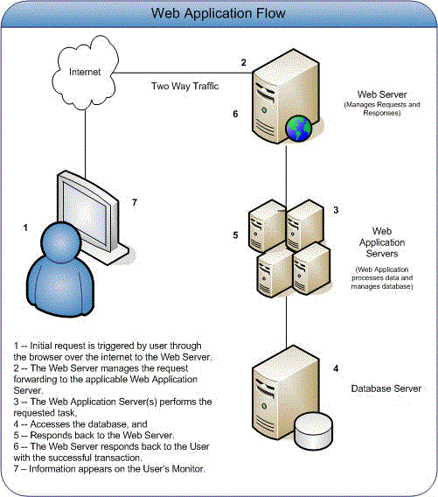

Fig 01: Megna Solar System Web Application Flow

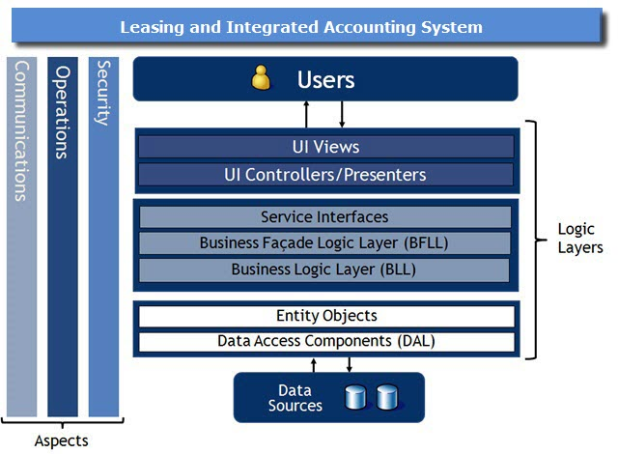

Fig: 02 Solution Architecture Diagram

**Product functions**

The following list offers a brief outline and description of the main features and functionalities of the Leasing and Integrated Accounting system.

|  |  |  |
| --- | --- | --- |
| **Sl. no.** | **Items** | **Summary** |
| 1 | General Configuration | General Configuration is the major part of **Leasing & Integrated Accounting System**. This system provide the integrated solution for keeping track of the company information and it’s a one way process for setup the company rules and regulation. It includes all branches as well.  Features:   1. Company Information 2. Branch Information (Multiple Branch maintenance by one database) 3. Define Accounting Method 4. Define Accounts Posting Method 5. Setting Accounting Period 6. Cards    1. Customer Information    2. Vendors/Supplier Information. 7. Analyzing Business Rules. |
| 2 | Integrated Accounting System | It automatically prepares the financial Statement like Cash Book, Bank Book, Ledger, Balance Sheet, Trial Balance, Profit and Loss, Budgeting and analysis etc.  Features:   1. Preparing Chart of Accounts as Branch wise 2. Control & Ledger Accounts Creation (Ledger/Group Control Account) 3. Define Cash & Bank Account 4. Define Accounts Receivable, Accounts Payable 5. Define Purchase Accounts 6. Define Sell Accounts 7. Define Bank Account Information 8. Bank Accounts Link to Chart of accounts 9. Cheque Book and Cheque Leaf Information 10. Prepare Payment, Receipt and Journal Voucher. 11. Voucher Posting 12. Define Fiscal Year   Reports:   1. Chart of Accounts List 2. Transaction History 3. Journal, Ledger, Balance Sheet, Trial Balance Statements 4. Cash & Bank Book Statements 5. Voucher Entry Report 6. Accounts Receivable and Accounts Payable Statements 7. Profit and Loss statement |
| 3 | Leasing Management | Leasing Management is important part of **Leasing & Integrated Accounting System** this system manages their leased, tracking of customer ledger and sales collection history.    Features:   1. Leasing agreement system 2. Customer Ledger maintain 3. Monthly collection   Reports:   1. Leasing agreement sheet 2. Customer Ledger 3. Monthly sales collection |
| 4 | Security Management | 1. Group Creation, Deletion and Updating with change password, termination option 2. User Creation, Deletion and Updating with change password, termination option 3. Providing Permission Group and user basis |
| 5 | Employee Management | Employee Transfer Log  Employee Management |
| 6 | Inventory Management | An efficient inventory management system rapidly responds to customer requirements and it is flexible enough to undertake any corrections when required. It does so without adversely affecting operational efficiencies. The Inventory Management module offers effective features to minimize warehousing costs and to optimize storage needs in line with the requirements in hand.  Features:   1. Opening Stock 2. Receiving Process 3. Head office Receiving Process 4. Disbursement Tracking 5. Transfer Tracking 6. Closing Inventory Status 7. Current Stock Status 8. Date wise stock Status, etc.   Reports:   1. Opening Stock Report 2. Closing Balance Report |

**User characteristics**

The Leasing and Integrated Accounting project is meant to offer a shared expenses solution that is faster, easier, and more convenient than manually calculating and handling debts. Consequently, the application will have little or no learning curve, and the user interface will be as intuitive as possible. Thus, technical expertise and .Net experience should not be an issue. Instead, anticipated users can be defined by how they will use the product in a particular situation. The following list categorizes the scenarios in which Megna Solar is expected to be utilized

1. Long-term recurring expenses (e.g. leasing)
   * + - Key functions:

Keep track of Installment

Notify users when debts are incurred

Record who has paid and who still owes

* + - * Requirements:

Method for inputting installment into the application

Support for automated notifications

Database containing current debts, past transactions, etc.

1. Short-term recurring expenses (e.g. official costs)
   * + - Key functions:

Add new expenses (quickly and easily)

Record who is paying and what he/she is paying for

Update Ledger balances

* + - * Requirements:

Simple and intuitive user interface for adding expenses

Voucher-tracking system

Automated, background algorithm for calculating Ledger

**Constraints**

* Handle large volume data
* High bandwidth Internet requirement
* Platform dependent
* Due to change Management requirement may change
* Synchronize Accounts to Inventory and Leasing data

**Assumptions and dependencies**

* It is assumed that the system will be developed using the ASP.NET technology.
* It is assumed that the system will interface with a SQL Server 2008 R2 database.
* It is assumed that organizations Provide good bandwidth Internet with Real IP.
* It is assumed that organizations provide windows Hosting system with goods space.

1. Target platform

* Application server
* Database Server ,SQL Server 2008 R2
* Crystal report 13
* Microsoft Visual Studio 2010
* Java Script, Jquery , HTML

1. Functional Requirements
2. Overview

|  |  |  |
| --- | --- | --- |
| Serial No | Main Functions | Description |
| 01 | General Configuration | This is the basic setting in this Project such as Company information, Employee Information .Product Setup ,Branch ,Area etc. |
| 02 | Inventory Management | Maintains Head office Inventory Stock , Branch Office stock, Tracking system for Inventory material challan, Collection efficiency, Recovery Rate, Advance and Partial collection, Installment collection etc. |
| 03 | Leasing Creation and Installment Tracking | Leasing agreement system, Customer Ledger maintain, Monthly collection Process etc |
| 04 | Accounting Management System | Chart of Accounts List, Transaction History , Journal, Ledger, Balance Sheet, Trial Balance Statements etc. |
| 05 | Employee Management | Employee Management, Employee Transfer Log |
| 06 | Security Management | Group Creation, Deletion and Updating with change password, termination option, User Creation, Deletion and Updating with change password, termination option etc. |

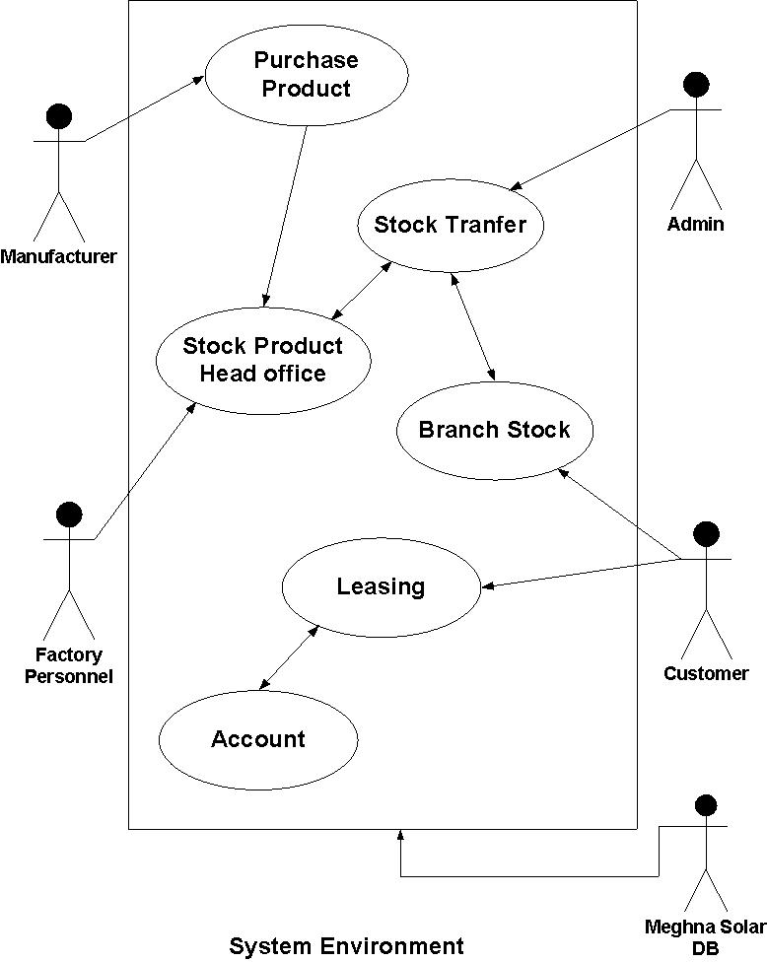

Fig 01: Use case for System Environment

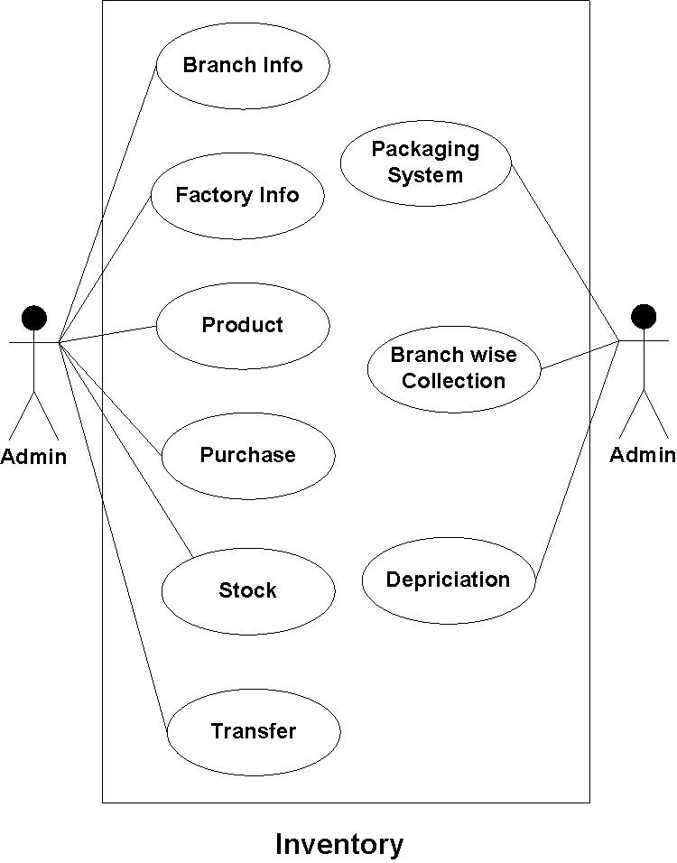

Fig 02: Use case for Inventory Management

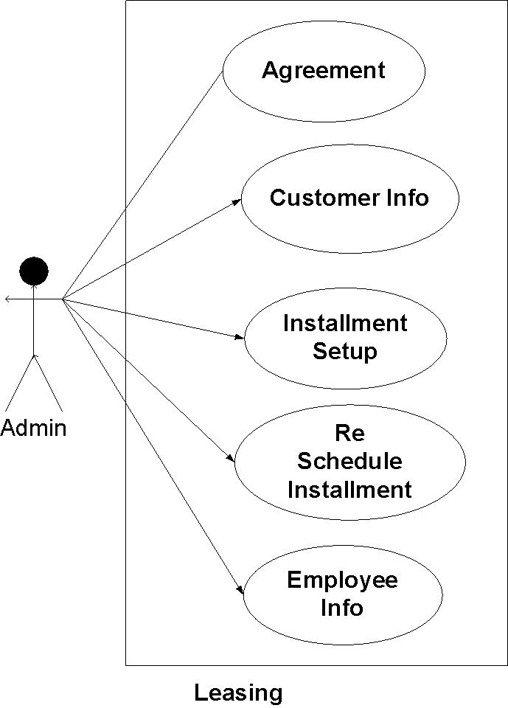

Fig 03: Use case for Leasing Management

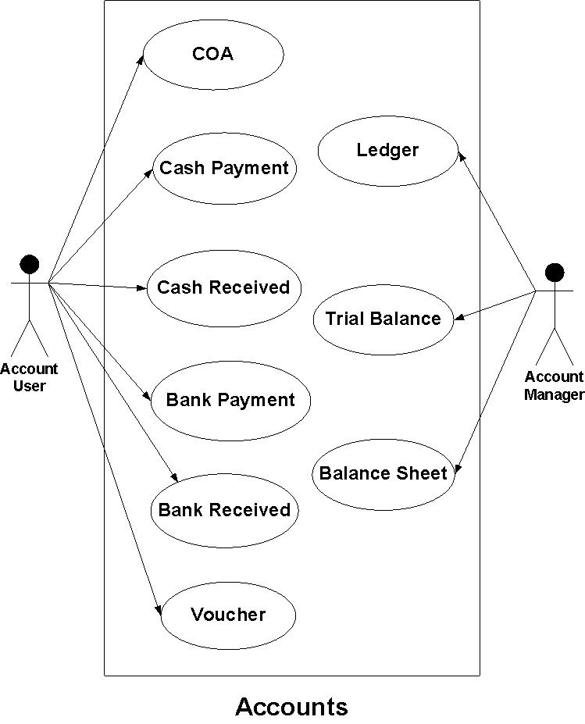

Fig 04: Use case for Accounts Management

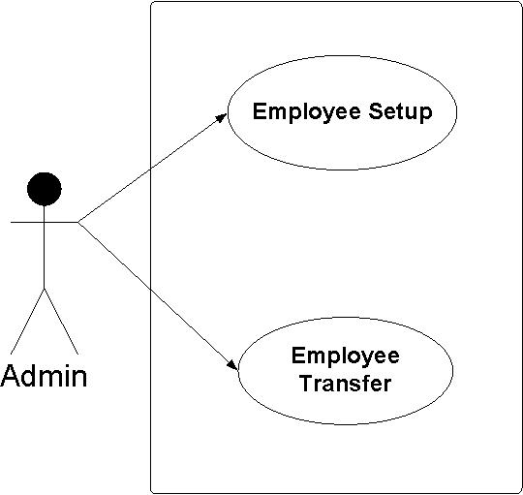

Fig 05: Use case for Employee Management

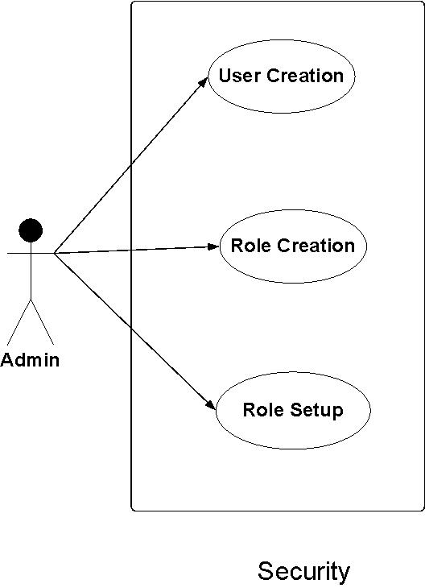

Fig 06: Use case for Security Management

* **General configuration UI:**

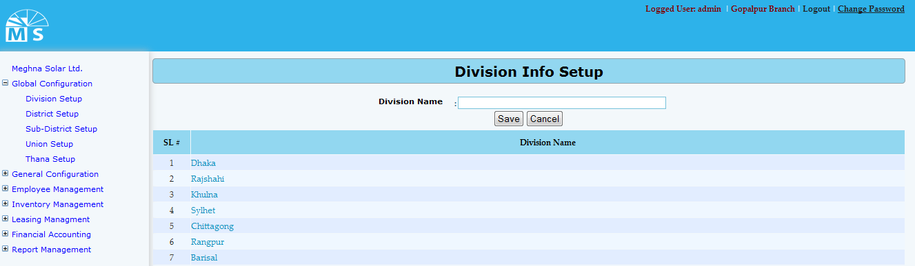

**Division Info Setup**

**Here user needs to enter Division Name in the text box and click Save Button to save the Division. Recently saved Divisions will be visible in the below grid view. For updating any Division user need to click on the Division name in the grid view. Then after modifying the division info in the text box, user need to Press Update button. After this, modified division name can be seen in the grid view.**

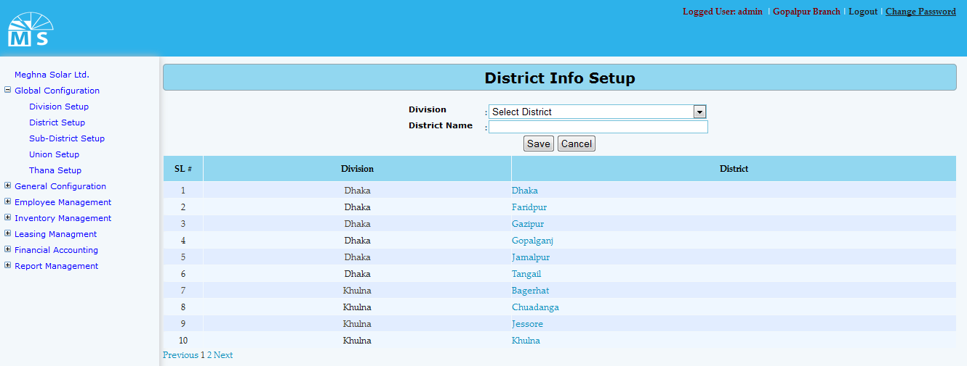

**District Info Setup**

**Here user needs to select Division name from the division dropdown list. Then enter District Name under that Dvision in the text box and click Save Button to save the District. Recently saved District will be visible in the below grid view. For updating any District user need to click on the District name in the grid view. Then after modifying the Division and District info in the text box, user need to Press Update button. After this, modified District name can be seen in the grid view.**

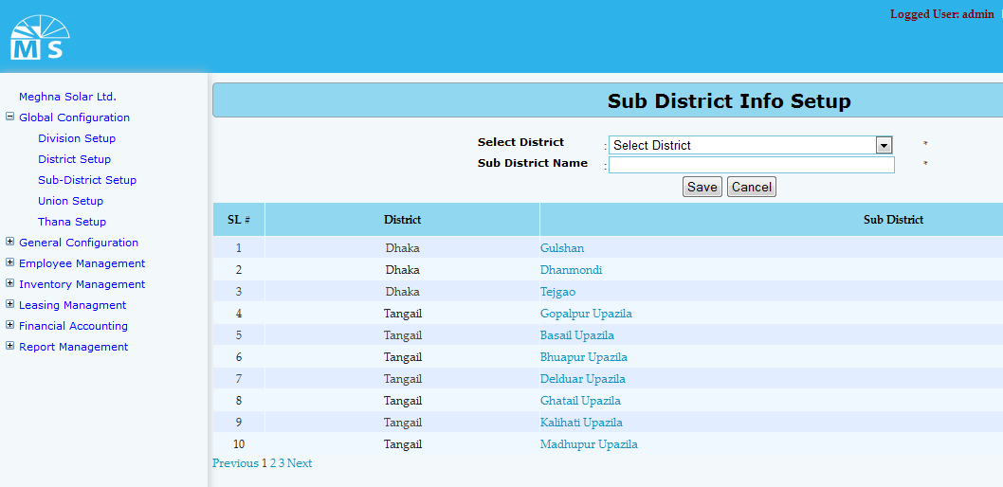

**Sub District Info Setup**

**Here user needs to select District name from the District dropdown list. Then enter Sub District Name under that District in the text box and click Save Button to save the Sub District. Recently saved Sub District will be visible in the below grid view. For updating any Sub District user need to click on the Sub District name in the grid view. Then after modifying the District and Sub District info in the text box, user need to Press Update button. After this, modified Sub District name can be seen in the grid view.**

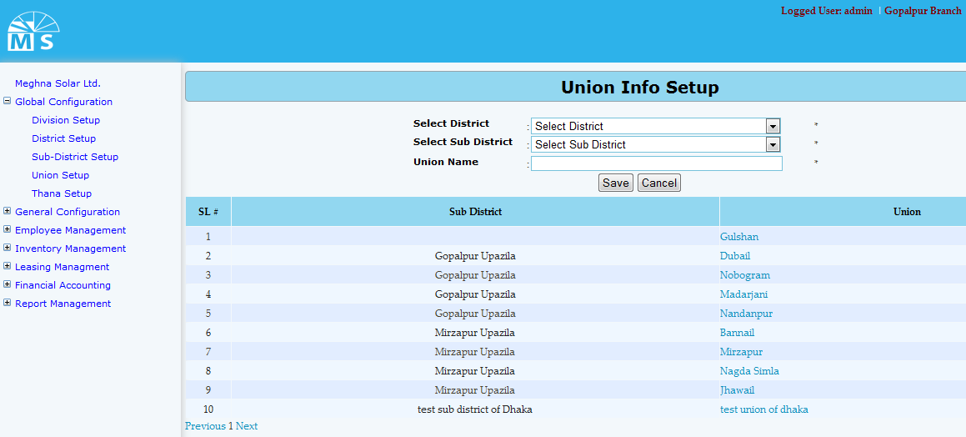

**Union Info Setup**

**Here user needs to select District name and Sub District name from the following dropdown list. Then enter Union Name under that District and Sub District in the text box and click Save Button to save the Union. Recently saved Union will be visible in the below grid view. For updating any Sub District user need to click on the Union name in the grid view. Then after modifying the District, Sub District and Union info in the text box, user need to Press Update button. After this, modified Union information can be seen in the grid view.**

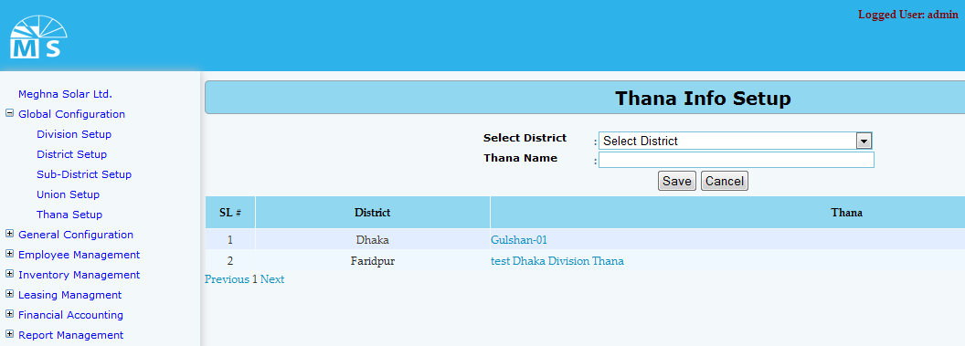

**Thana Info Setup**

**Here user needs to select District name from the following dropdown list. Then enter Thana Name under that District in the text box and click Save Button to save the Thana. Recently saved Thana will be visible in the below grid view. For updating any Thana user need to click on the Thana name in the grid view. Then after modifying the District and Thana info in the text box, user need to Press Update button. After this, modified Thana information can be seen in the grid view.**

* **General configuration tables**

Table Name: Division

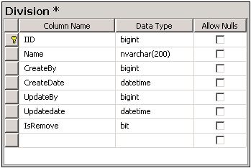

Table Name: District

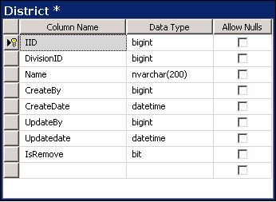

Table Name: Sub District

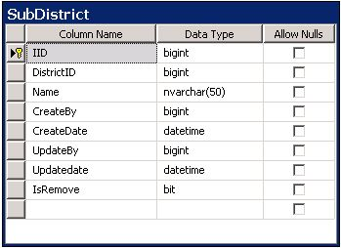

Table Name: Thana

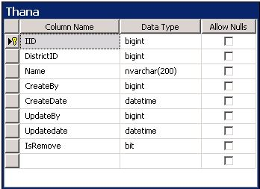

Table name: Union

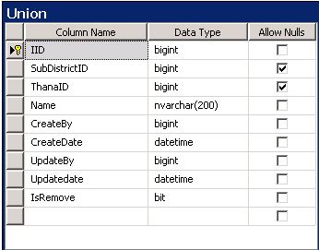

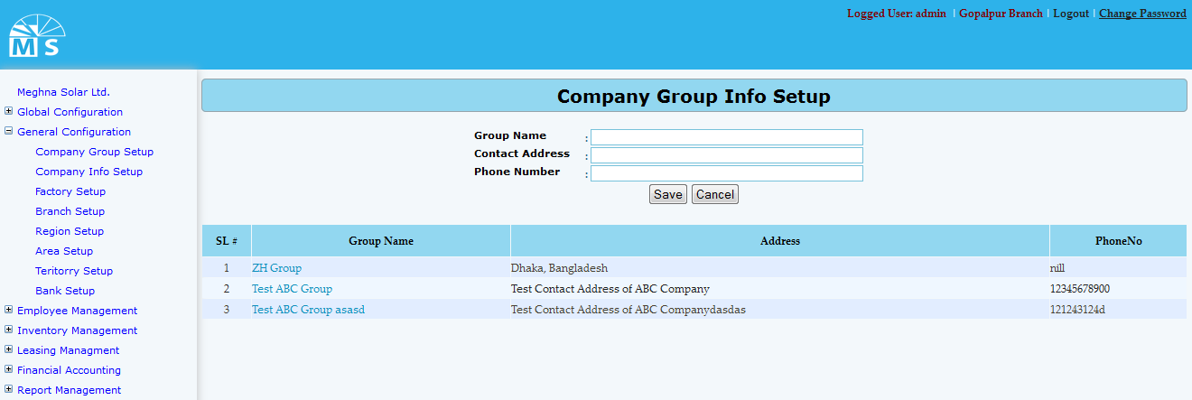

**Company Group Info Setup**

**Here user needs to enter Group Name, Contact Address and Phone No. in the text box and click Save Button to save Company group information. Recently saved Company group information will be visible in the below grid view. For updating any information user need to click on the Group name in the grid view. Then after modifying the division info in the Upper text box, user need to Press Update button. After this, modified Company group information will be seen in the grid view.**

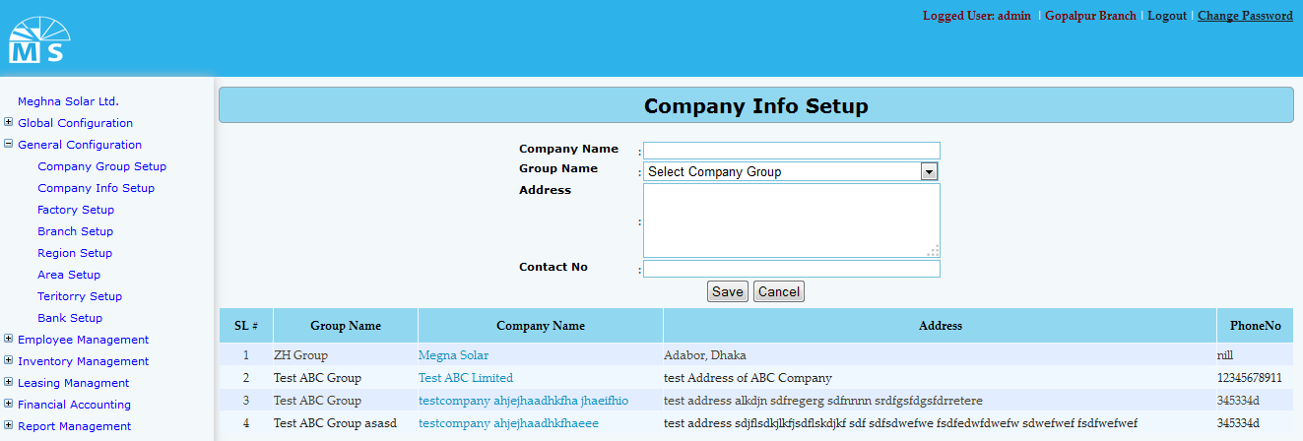

**Company Info Setup**

**Here user needs to enter Company name and select Group name from the dropdown list. Then enter Company address and contact no. in the text box and click Save Button to save Company Information. Recently saved Information will be visible in the below grid view. For updating any Company information user need to click on the Company name in the grid view. Then after modifying the information, user need to Press Update button. After this, modified Company information can be seen in the grid view.**

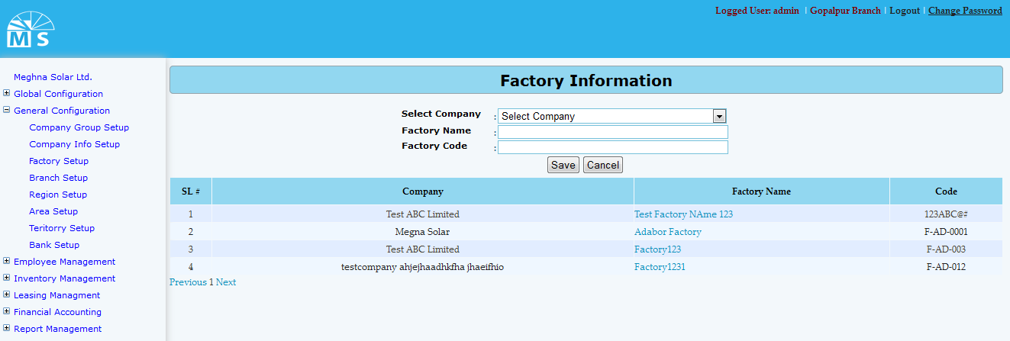

**Factory Info Setup**

**Here user needs to select Company name from the dropdown list. Then enter Factory Name and Factory Code in the text box and click Save Button to save Factory Information. Recently saved Factory Information will be visible in the below grid view. For updating any Factory Information user need to click on the Factory name in the grid view. Then after modifying the Factory Information user need to Press Update button. After that, modified Factory Information can be seen in the grid view.**

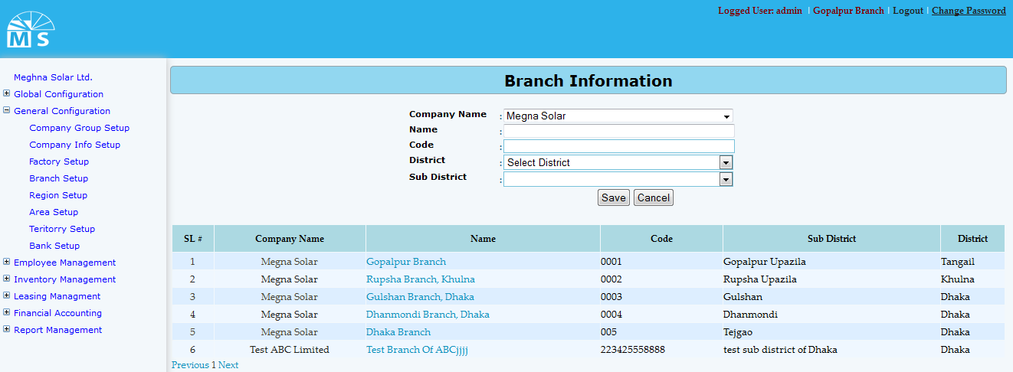

**Branch Info Setup**

**Here user needs to select Company name, District name and Sub District name from the following dropdown list. Then enter Branch name and Code in the text box and click Save Button to save the Branch. Recently saved Branch will be visible in the below grid view. For updating any Branch Information user need to click on the Branch name in the grid view. Then after modifying the Branch information, user need to Press Update button. After that, modified Branch information can be seen in the grid view.**

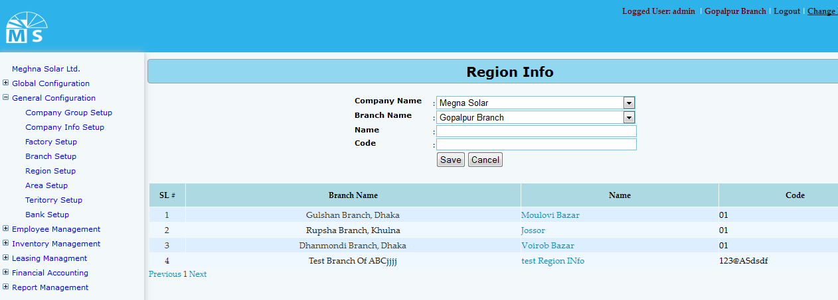

**Region Info Setup**

**Here user needs to select Company name and Branch name from the following dropdown list. Then enter Region name and code in the text box and click Save Button to save the Region. Recently saved Region will be visible in the below grid view. For updating any Region user need to click on the Region name in the grid view. Then after modifying the Region info in the text box, user need to Press Update button. After this, modified Region information can be seen in the grid view.**

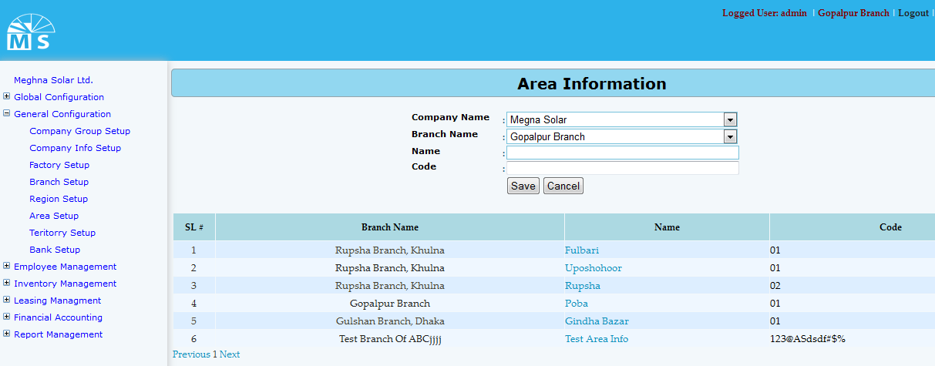

**Area info Setup**

**Here user needs to select Company name and Branch name from the following dropdown list. Then enter Area name and code in the text box and click Save Button to save the Area. Recently saved Area will be visible in the below grid view. For updating any Area user need to click on the Area name in the grid view. Then after modifying the Area info in the text box, user need to Press Update button. After that, modified Area information can be seen in the grid view.**

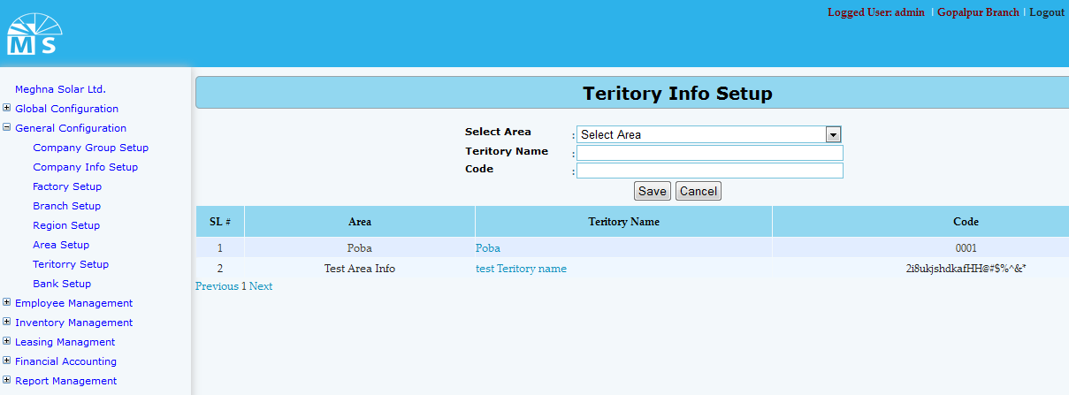

**Teritory Info Setup**

**Here user needs to select Company name and Branch name from the following dropdown list. Then enter Area name and code in the text box and click Save Button to save the Area. Recently saved Area will be visible in the below grid view. For updating any Area user need to click on the Area name in the grid view. Then after modifying the Area info in the text box, user need to Press Update button. After that, modified Area information can be seen in the grid view.**

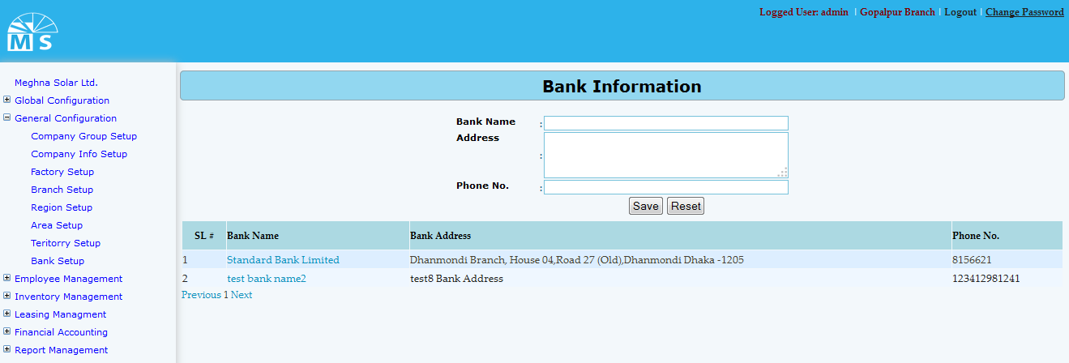

**Bank Info Setup**

**Here user needs to enter Bank name, Bank address and Phone No. in the text box and click Save Button to save the Bank. Recently saved Bank will be visible in the below grid view. For updating any Bank user need to click on the Bank name in the grid view. Then after modifying the Bank info in the text box, user need to Press Update button. After that, modified Bank information can be seen in the grid view**

**Table name: Company Info**

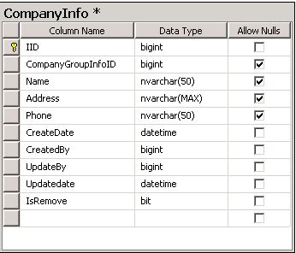

**Table name: Company group**

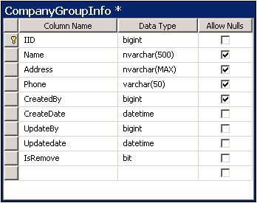

**Table name: Factory**

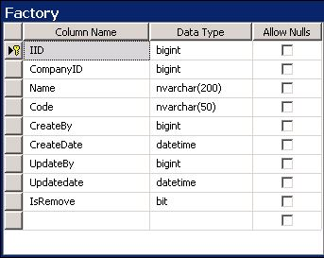

**Table name:Branch**

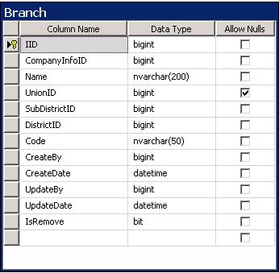

**Table name: Area**

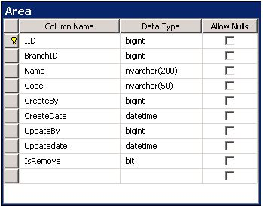

**Table name: Teritory**

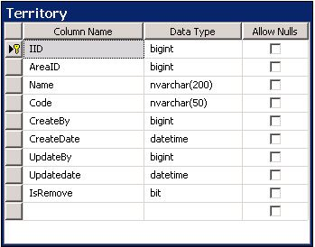

* **Employee Management UI:**

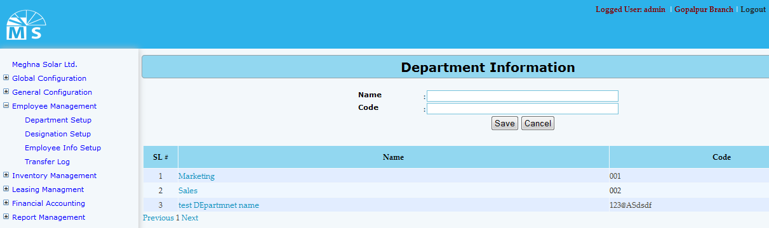

**Department Info Setup**

**Here user needs to enter Department name and Code in the text box and click Save Button to save Department information. Recently saved Department information will be visible in the below grid view. For updating any information user need to click on the Department name in the grid view. Then after modifying the Department info in the Upper text box, user need to Press Update button. After that, modified Department information will be available in the grid view.**

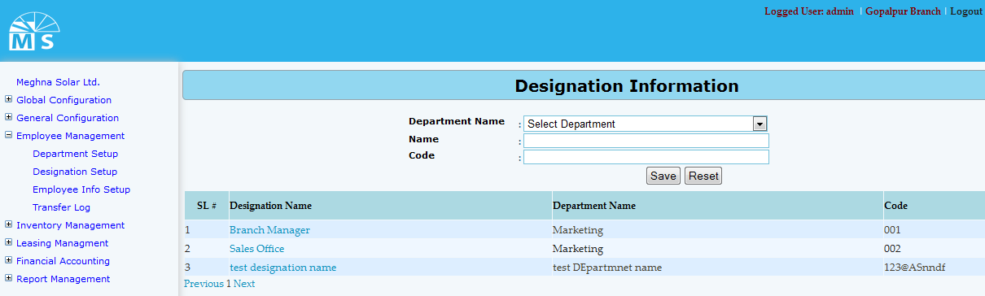

**Designation Info Setup**

**Here user needs to select Department name from the dropdown list. Then enter Designation name and code in the text box and click Save Button to save Designation Information. Recently saved Information will be visible in the below grid view. For updating any Designation information user need to click on the Designation name in the grid view. Then after modifying the information, user need to Press Update button. After that, modified Designation information can be seen in the grid view.**

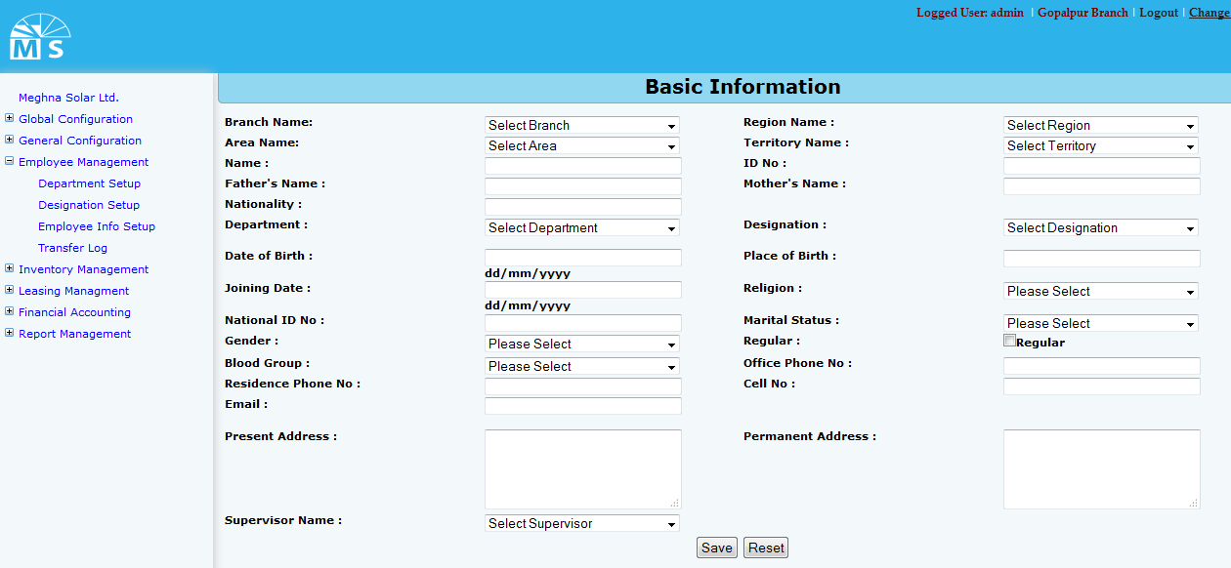

**Employee Info Setup(Basic Information)**

**Here user needs to enter Employ’s basic information. For that top of the entry form user need to select Branch, Region, Area and Territory name from the dropdown list. Then user need to entry employ’s name, ID no., Employ’s Father’s name, mother’s name and nationality in the text box . After that user need to select department name and Designation from drop down list and enter Date of birth, place of birth and Joining Date. Then after selecting religion,Maritial Status, gender and blood group from drop down list user need to enter National Id no., employ’s contact no., email address, present and permanent address in the text box.At last User need to select a Supervisor of that emplyee from Supervisor name drop down list .**

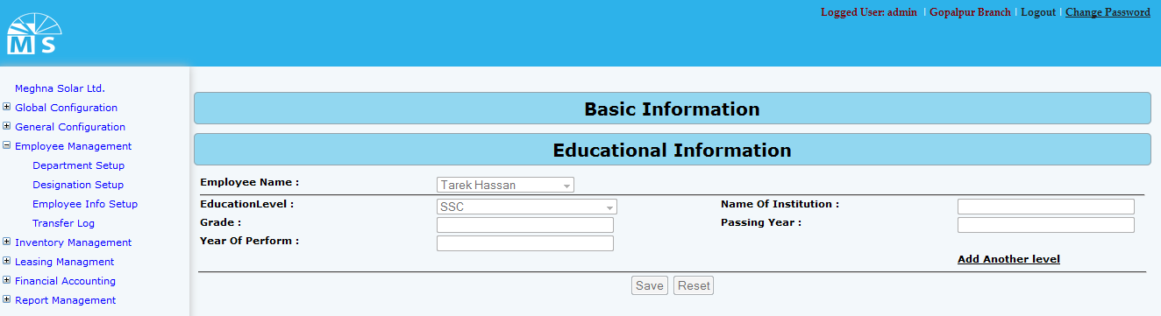

**Employee Info Setup(Educational Information)**

**For entering educational information of an emplloyee user need to select employee from Employee dropdown list. Then for each education level user need to selelct from drop down list (ex: JSC, SSC, HSC, Masters etc.). User also need to enter Institution name, Grade,Passing Year and year of Perform in the following text field.**

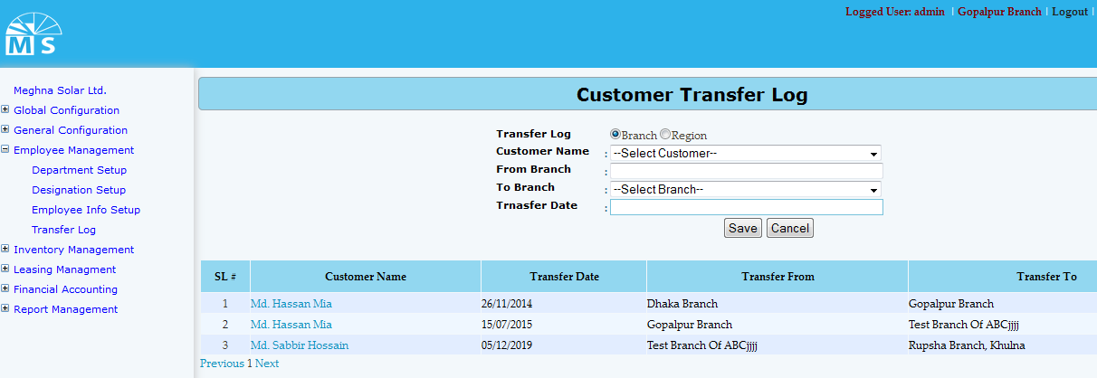

**Customer Transfer Log (Branch wise)**

**Here user first needs to decide whether to insert data Branch wise or Region wise. According to that, branch and region should be sellected from the top radio button sellection. Then user need to select Customer name from the dropdown list. After that user need to enter From and to branch and transfer Date in the text boc and click Save Button to save transfer log. Recently saved Transfer Log will be visible in the below grid view. For updating user need to click on the Customer name in the grid view. Then after modifying the info in the text box, user need to Press Update button. After that, modified Transfer Log information can be seen in the grid view.**

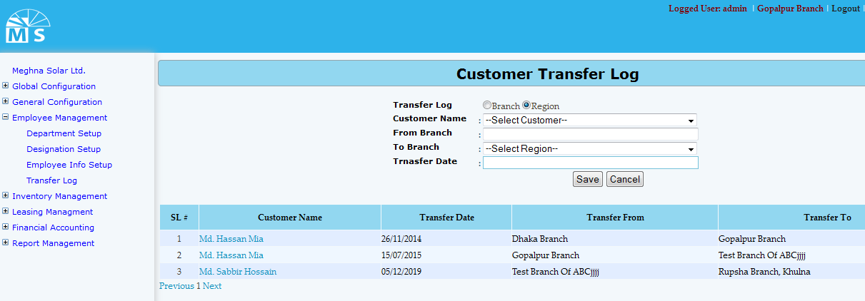

**Customer Transfer Log (Region wise)**

**Here user needs to select Region from the second drop down list, enter other information and click Save Button to save Customer Transfer Log. Recently saved information will be visible in the grid view. For updating any informartion user need to click on customer name in the grid , modify info in text box and click update button to see modified info in the grid view.**

* **Employee management tables**

**Table name: Department**

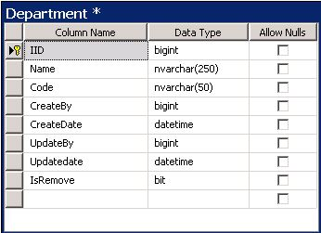

**Table name: Designation**

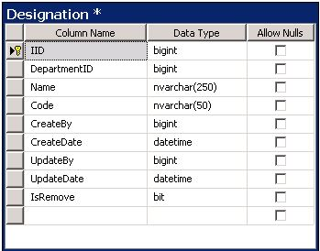

**Table name: Employee info**

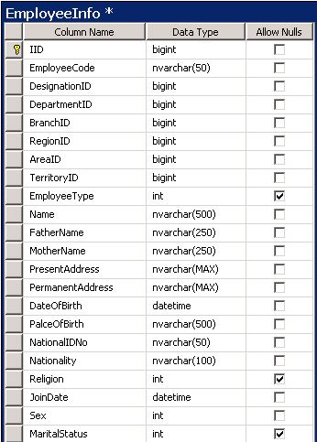

**Table name: Employee education info**

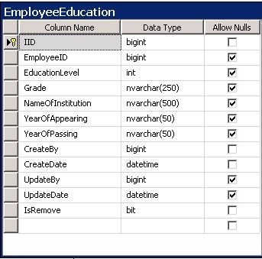

**Table name: Customer transfer**

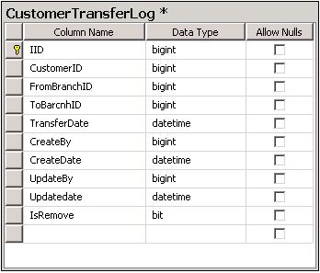

* **Inventory Management UI:**

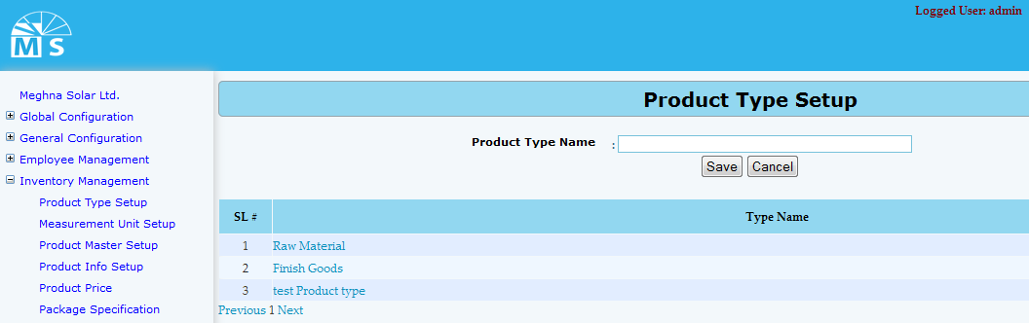

**Product type Setup**

**Here user needs to enter Product type name in the text box and click Save Button to save Product type name information. Recently saved Product type information will be visible in the below grid view. For updating any information user need to click on Type name in the grid view. After modifying the name, user need to Press Update button. After that, modified Product type information will be available in the grid view.**

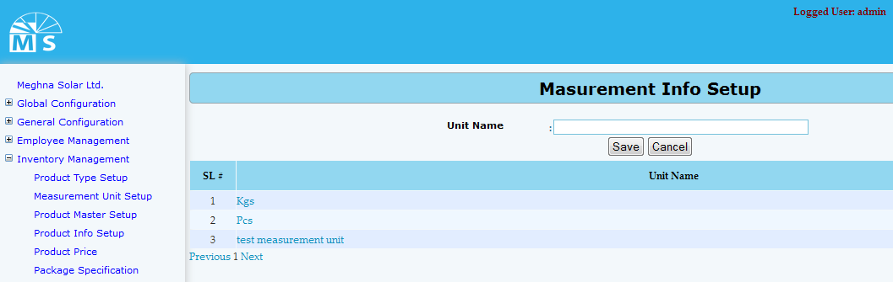

**Measurement unit Setup**

**Here user needs to enter Measurement unit name in the text box and click Save Button to save Measurement unit name information. Recently saved Measurement unit information will be visible in the below grid view. For updating any information user need to click on unit name in the grid view. After modifying the name, user need to Press Update button. Then, modified Measurement unit information will be available in the grid view.**

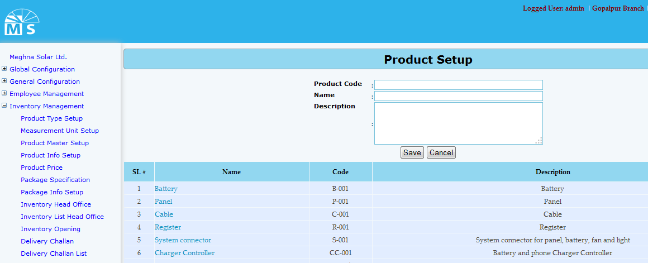

**Product master setup**

**Here user needs to enter Product Code, Product name and Product description in the text field. Then user need to click Save Button to save Product master setup information. Recently saved information will be visible in the grid view. For updating any informartion user need to click on Product name in the grid , modify info in text box and click update button to see modified info in the grid view.**

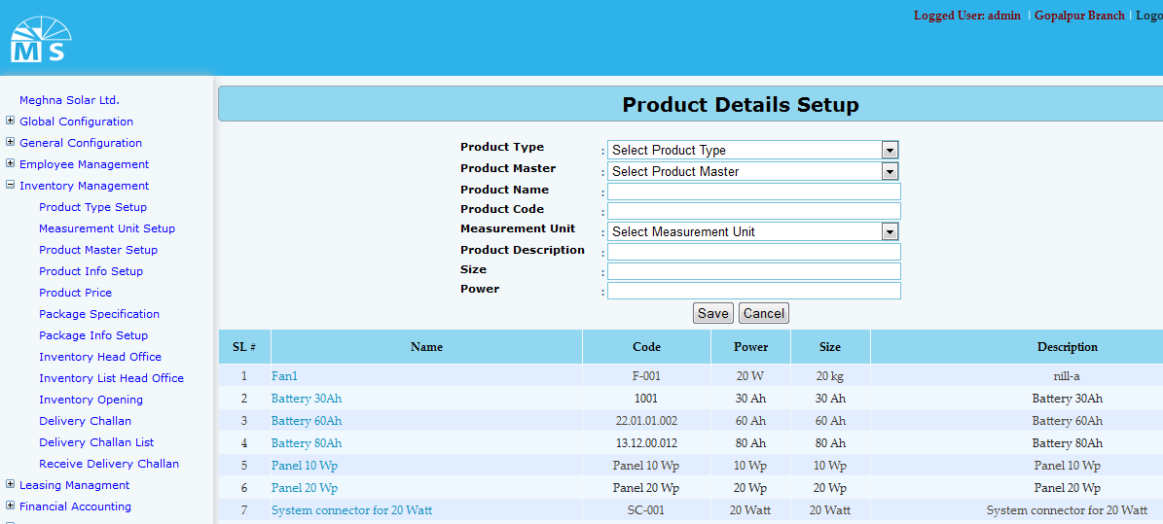

* **List of DCM Tables:**

|  |  |
| --- | --- |
| **Sl No** | **Name of the table** |
|  | **DIST_DISTRIBUTION_PLAN** |
|  | DIST_NO_OF_CCLINIC_SETUP |
|  | INDENTS |

**Product Details setup**

**Here user needs to select Product Type and Product Master form the top two drop down list. Then enter Product Code, Product name . After that selecting measurement unit from dropdown list user also neeed to enter product description, Size and Power in the text field. Then user need to click Save Button to save Product details information. Recently saved information will be visible in the grid view. For updating any informartion user need to click on Product name in the grid , modify info in text box and click update button to see modified info in the grid view.**

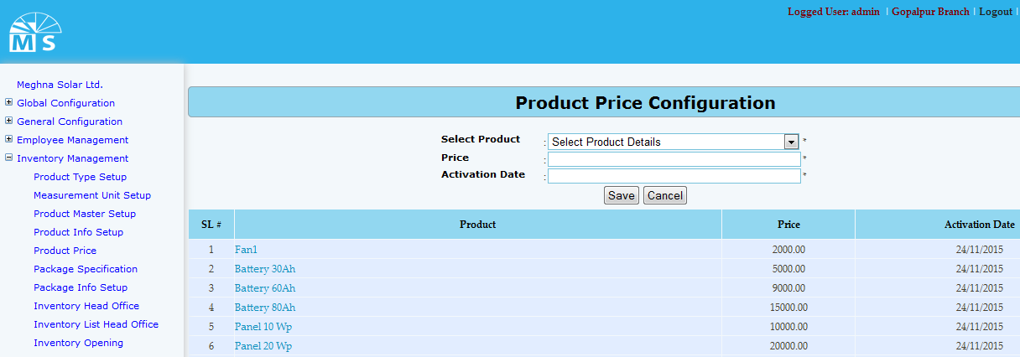

**Product Price Configuration setup**

**Here user needs to select Product form the top drop down list. Then enter Product price and Activation date. Then user need to click Save Button to save Product Price information. Recently saved information will be visible in the grid view. For updating any informartion user need to click on Product name in the grid , modify info in text box and click update button to see modified info in the grid view.**

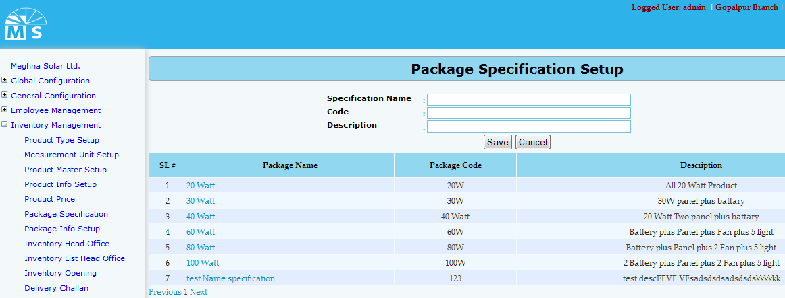

**Package Specification setup**

**Here user needs to enter Specification name, code and description in the text box. Then user need to click Save Button to save Package Specification information. Recently saved information will be visible in the grid view. For updating any informartion user need to click on Package name in the grid , modify info in text box and click update button to see modified info in the grid view.**

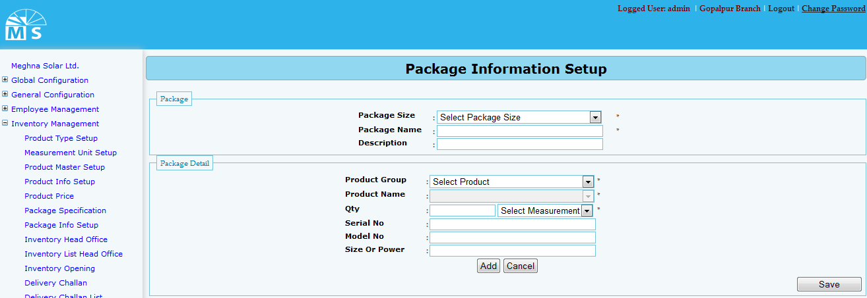

**Package Information setup**

**Here in package section user needs to select package size from the drop down list and enter Package name and Description. Then in Package Detail user need to selelct product group, product name,Quantity,Measurement Unit from drop down list. Then he need to enter serial no,model no and size or power value in texbox. If user click Add button then the pakage detail will be visible in the gridview. Like this user can add more than one details. At last user need to click Save button to save the Package information.**

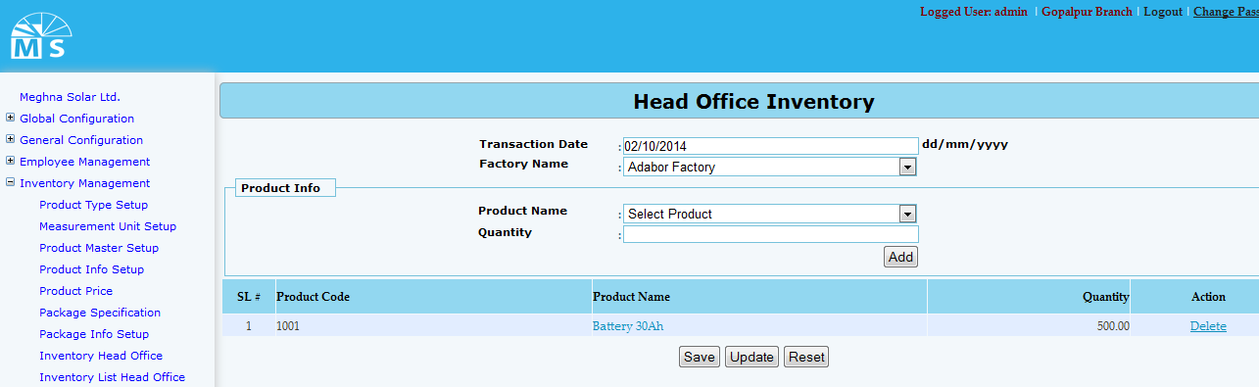

**Head Office Inventory**

**Here in Head Office Inventory user need to enter transaction date and select factory name from drop down list. Then in Product Info section User need to select product name from drop down list and enter quantity value to add product in the gridview. Besides adding product User can also delete product from gridview. Then at last User need to press save button to save the whole Inventory information.**

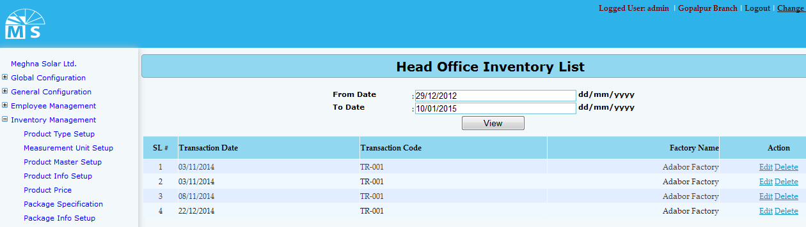

**Head Office Inventory List**

**Here in Head Office Inventory List user can search/view inventory list by inserting from date and to date. After clicking view button inventory list between the dates will be shown in the grid. From there user can edit or delete inventory details.**

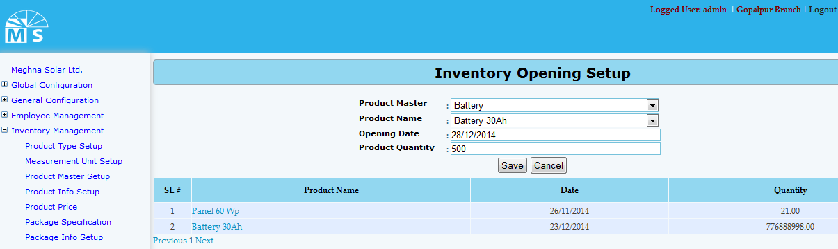

**Inventory Opening Setup**

**Here in Inventory Opening Setup user need to enter Product master and product name from drop down list. Then need to enter opening date and product quantiy to save Inventory Opening Setup information. After clicking save button information will be visible in the gridview. For updating user need to click on product name to update any information.**

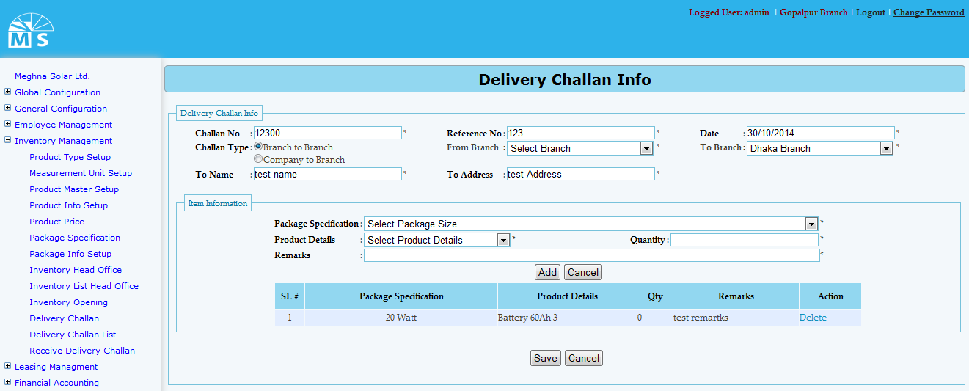

**Delivery Challan Info**

**Here in Delivery Challan Info there is two section. At first in delivery challan info section user need to enter challan no, referrence no,challan type, date, branch, to name and challan address. Then in Item info section user need to sellect package specification and package detail from drop down list. Then user need to enter quantity and remarks to add item info in grid. User can add more than one item info. At last user need to click save button to save delivery challan info.**

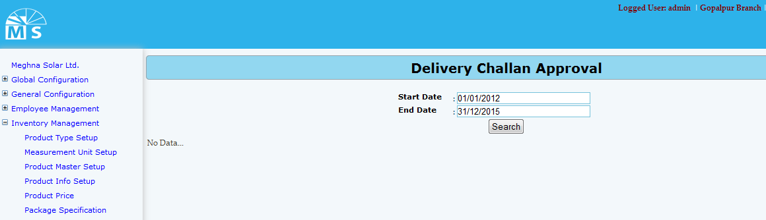

**Delivery Challan Approval**

**Here in Delivery Challan Approval user can search delivery challn info date wise. After providing Start and end date user need to click search button. Then the delivery challn info become visible in the grid view.**

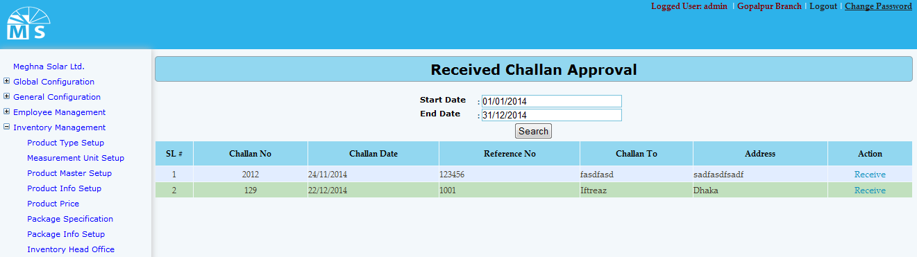

**Received Challan Approval**

**Here in Received Challan Approval user can search receive challn date wise and also can approve them as well. For that user need to enter start and end date and click search button. Then received challn between the date range will be visible in the grid. Fron there user can receive Challan.**

* **Inventory Mangement tables**

**Table name: Product Type**

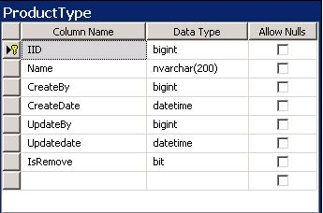

**Table name: Measurement**

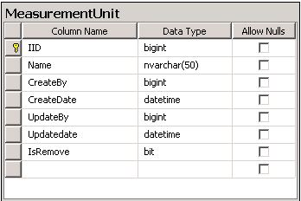

**Table name: Product Master**

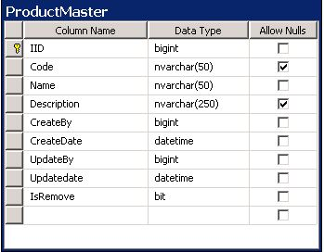

**Table name: Product Details**

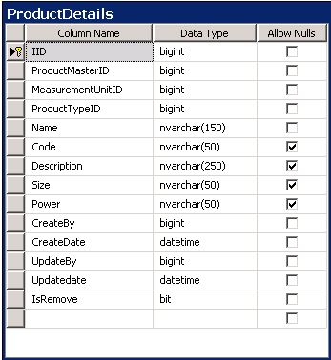

**Table name: Product Price**

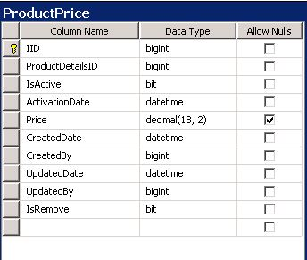

**Table name: Package specification**

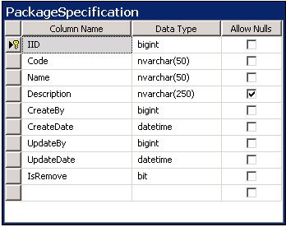

**Table name: Inventory Master**

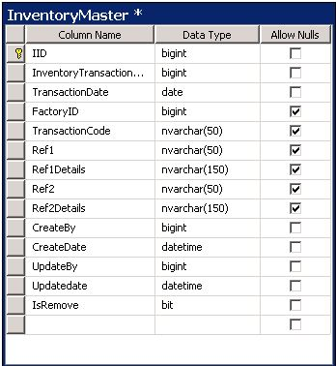

**Table name: Inventory Opening**

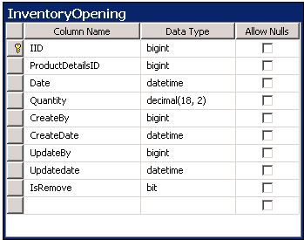

**Table name: Delivery Challan**

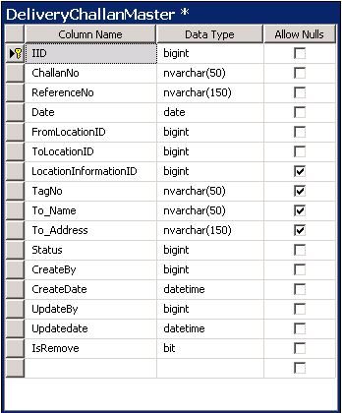

* **Financial Accounting UI:**

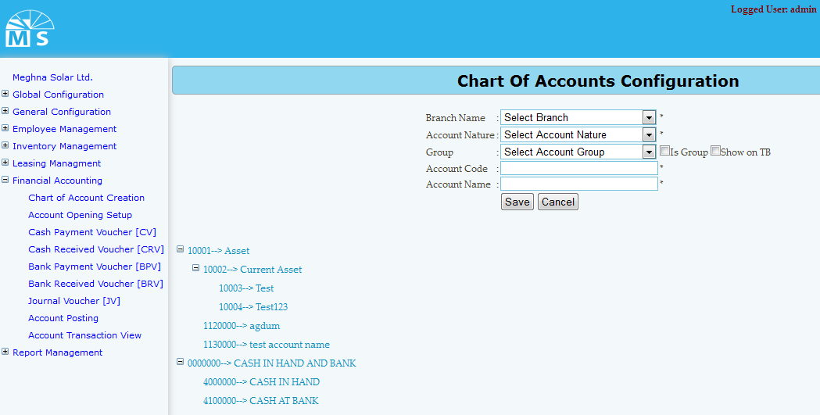

**Chart of Accounts Configuration**

**Here user needs to select branch name, Account nature, and group from drop down list. Then user also needs to enter account code and account name to save chart of accounts configuration. Saved chart of accounts configuration will be visible below in tree diagram. If modification needed, user can click on the tree branch to modify information.**

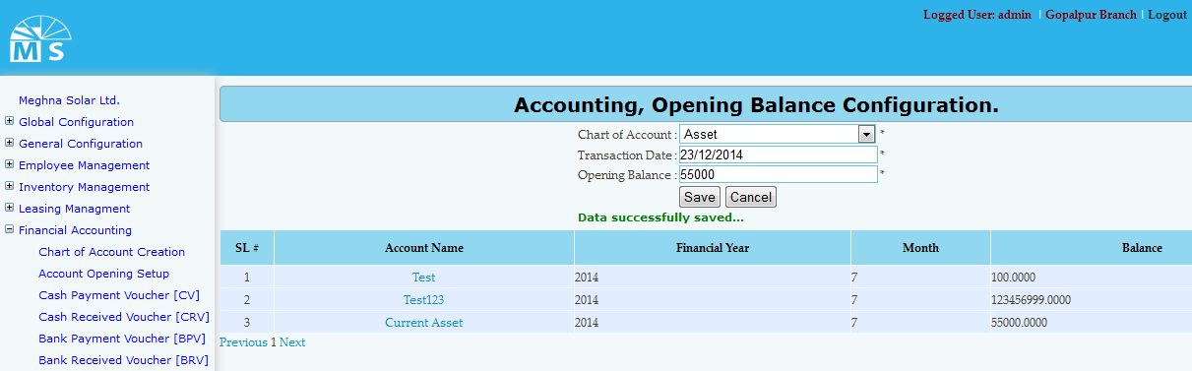

**Account opening Setup**

**Here user needs to select chart of account from the drop down list then need to enter transaction date and opening balance to save opening balance info. After clicking save button information will be visible in the grid view. For any modification user need to click on account name in the grid view. After modifying information, user need to Press Update button. Then, modified information will be available in the grid view.**

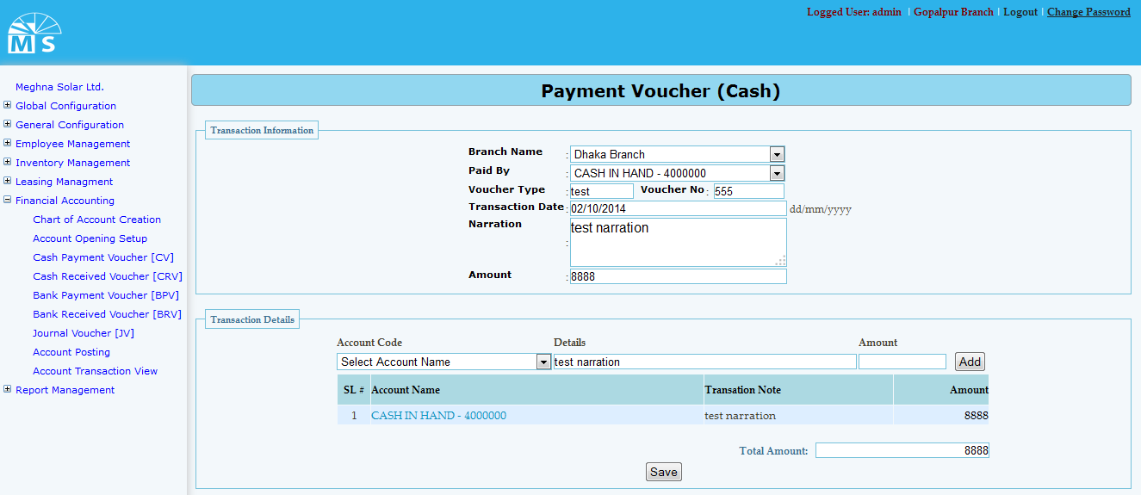

**Payment Voucher (CV)**

**Here in Payment Voucher cash, there are two section. At first in transaction information section user needs to select branch name and paid by from drop down list. Then user also need to enter Voucher type, voucher no, transaction date, narration and ammount. Then in Second section named Transaction detail user need to add transaction detail information. For that user need to selelct accounr code from drop down and enter details and amount to add info. Added info will be visible in grid. Below Total amounrt will be shown. Then user need to click Save Button to save Payment Voucher (CV) information.**

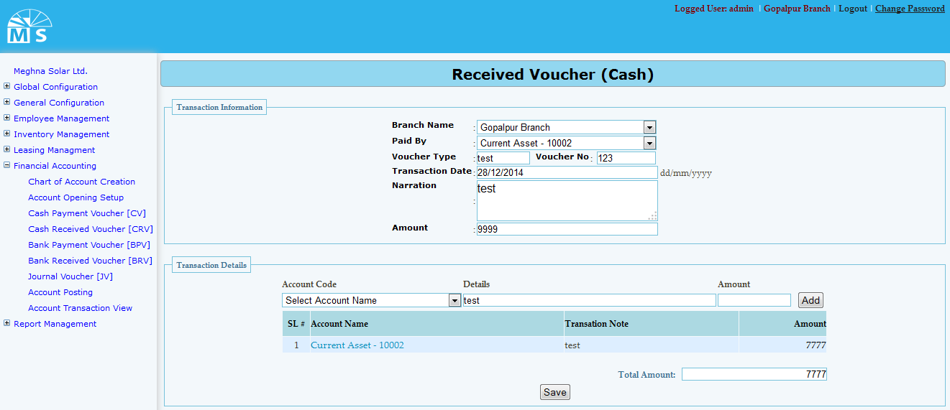

**Cash Receive Voucher**

**Here in Cash receive voucher user needs to select branch name and paid by from drop down list. Then user also need to enter Voucher type, voucher no, transaction date, narration and ammount in first section. Then in Second section named Transaction detail user need to add transaction detail information. For that user need to selelct accounr code from drop down and enter details and amount to add info. Added info will be visible in grid. Below Total amounrt will be shown. Then user need to click Save Button to save Cash Receive Voucher information.**

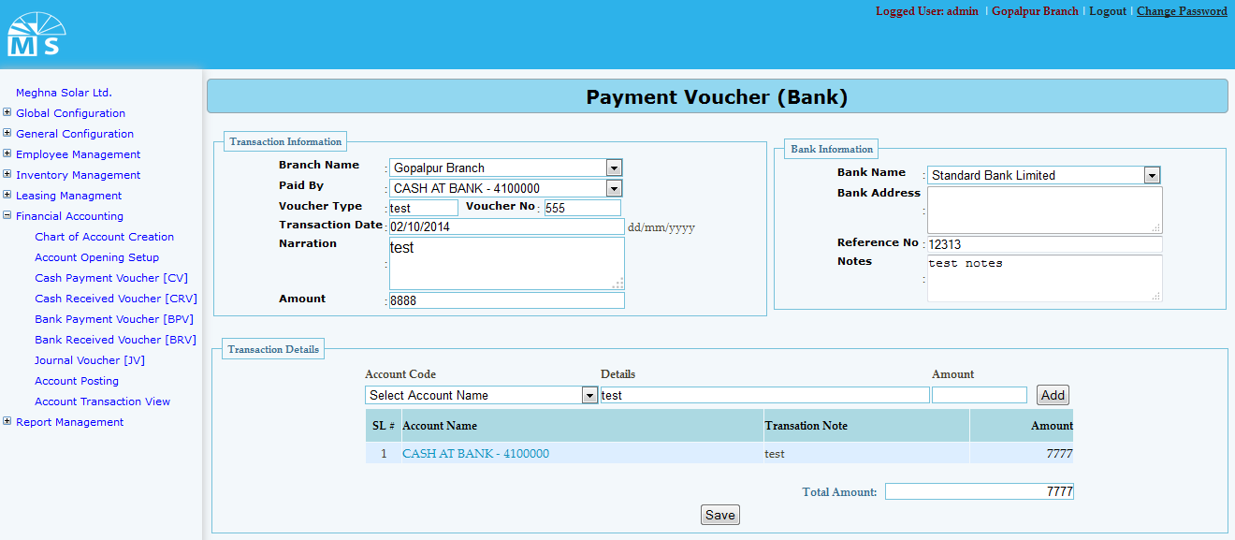

**Bank Payment Voucher**

**Here we have three section Traction information, Bank information and transaction details. User user needs to select branch name and paid by from drop down list. Then user also need to enter Voucher type, voucher no, transaction date, narration and amount in first section. In second section user need to enter Bank information like Bank name, address, referrence no and note details.Then in Third section named Transaction detail user need to add transaction detail information. For that user need to selelct accounr code from drop down and enter details and amount to add info. Added info will be visible in grid. Below Total amounrt will be shown. Then user need to click Save Button to save Bank Receive Voucher information.**

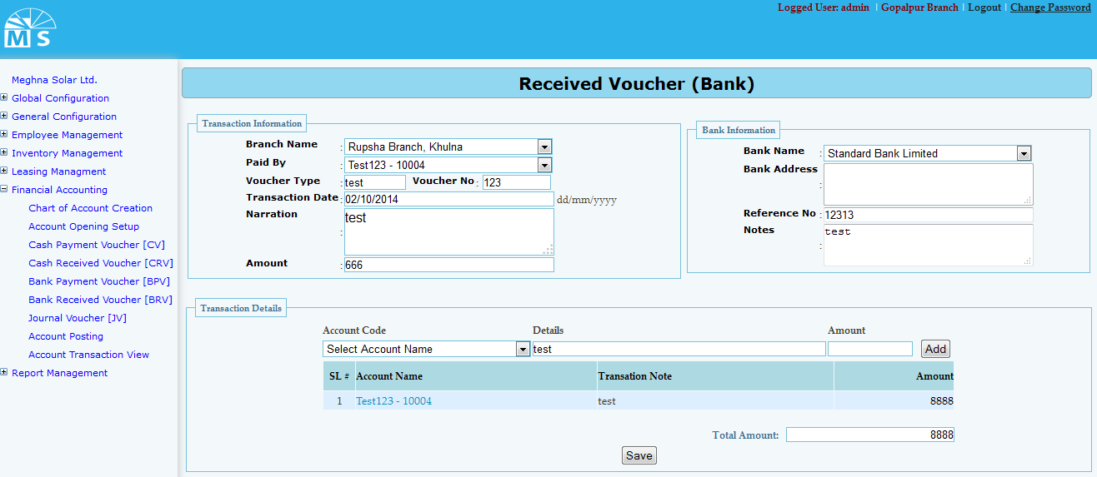

**Bank Receive Voucher**

**Here we also have three sections. User user needs to select branch name and paid by from drop down list. Then user also need to enter Voucher type, voucher no, transaction date, narration and amount in first section. In second section user need to enter Bank information like Bank name, address, referrence no and note details.Then in Third section named Transaction detail user need selelct accounr code from drop down and enter details and amount to add info. Added info will be visible in grid. Below Total amounrt will be shown. Then user need to click Save Button to save Bank Receive Voucher information.**

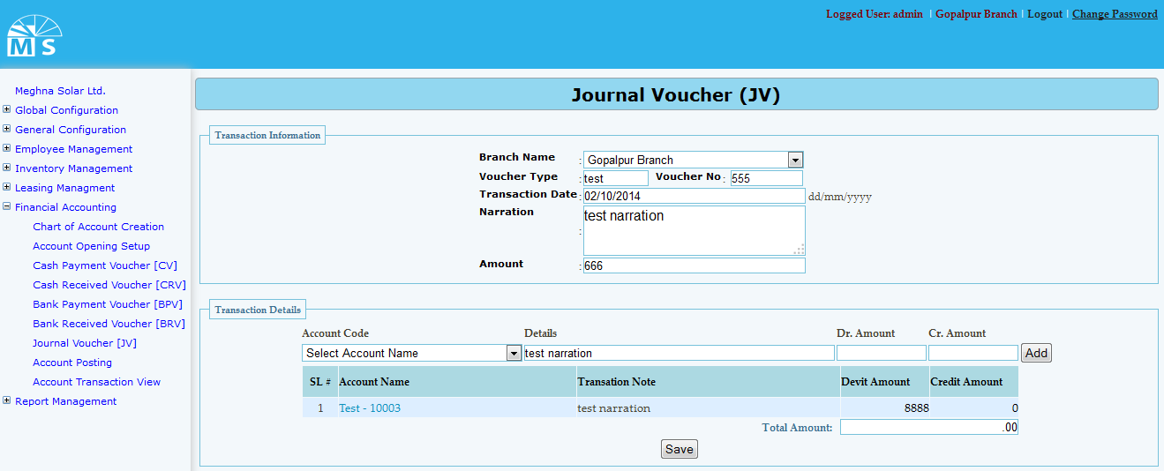

**Journal Voucher**

**Here in Journal voucher user needs to select branch name from drop down list. Then user also need to enter Voucher type, voucher no, transaction date, narration and ammount in first section. Then in Second section named Transaction detail user need to add transaction detail information. For that user need to selelct accounr code from drop down list, enter details and amount to add info. Added info will be visible in grid. Below Total amounrt will be shown. Then user need to click Save Button to save Journal Voucher information.**

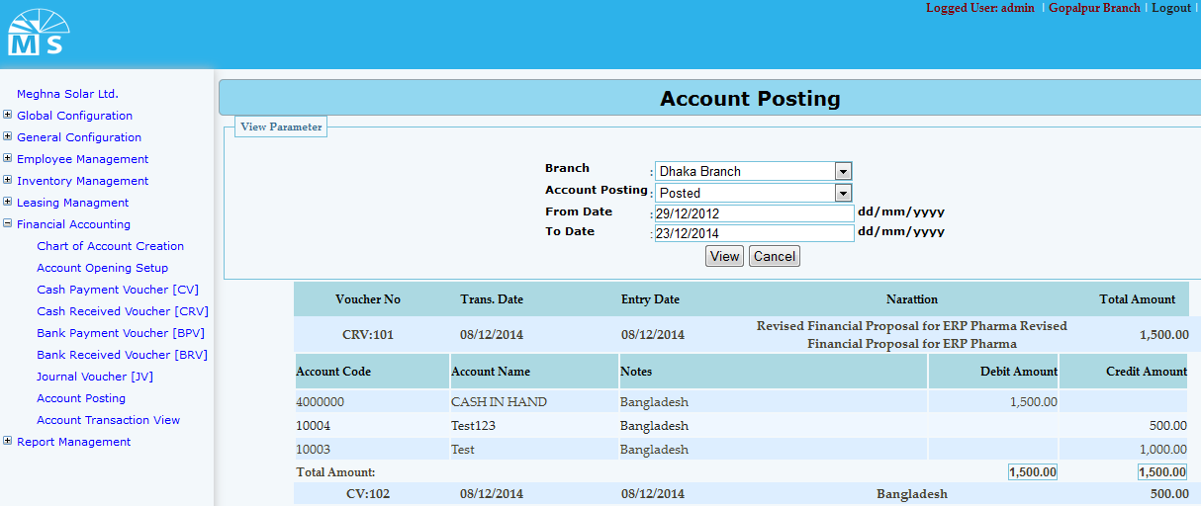

**Account Posting**

**Here in Account Posting section user need to select branch and account posting from drop down list.Then user need to enter date range and click view button. After that account information will be visible in the grid view below.**

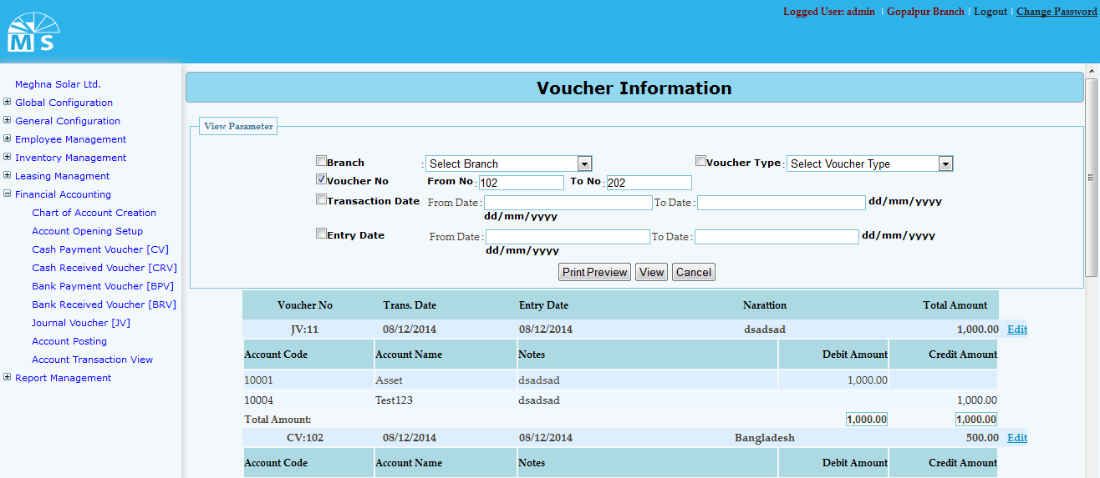

**Account transaction view**

**Here in Account transaction view user can print, view voucher information by selecting different cryteria in view parameter section. The parameters are branch name, voucher type, voucher no, transaction date and entry date.**

* **Financial Accounting Tables**

**Table name: Chart of account**

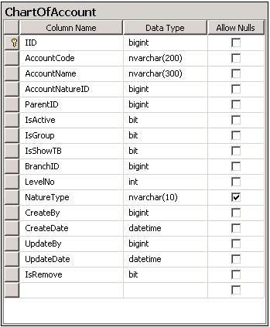

**Table name: Account Opening**

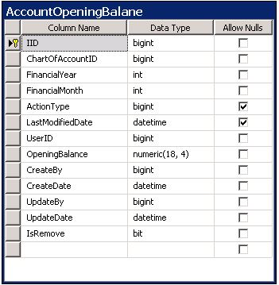

**Table name: Account Voucher**

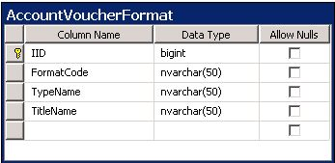

**Table name: Account Transaction**

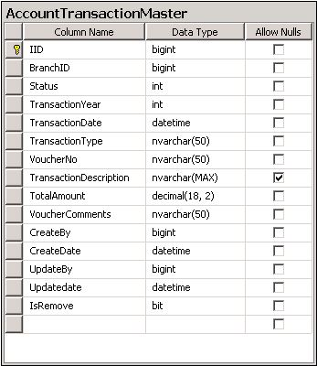

* **Leasing UI**

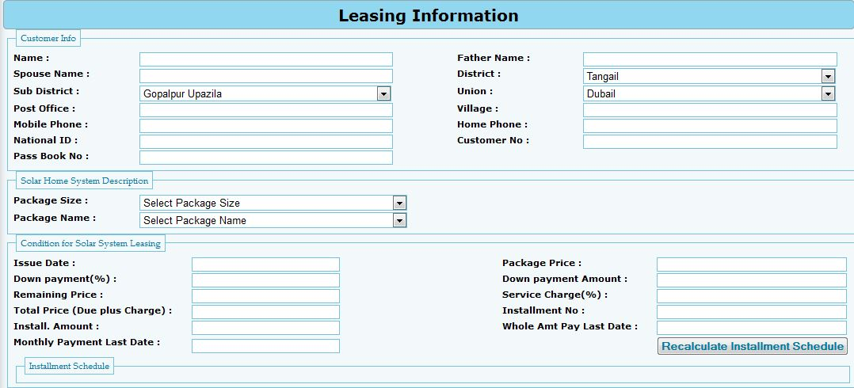

**Leasing Information**

**Here is the form for leasing iNformation entry**

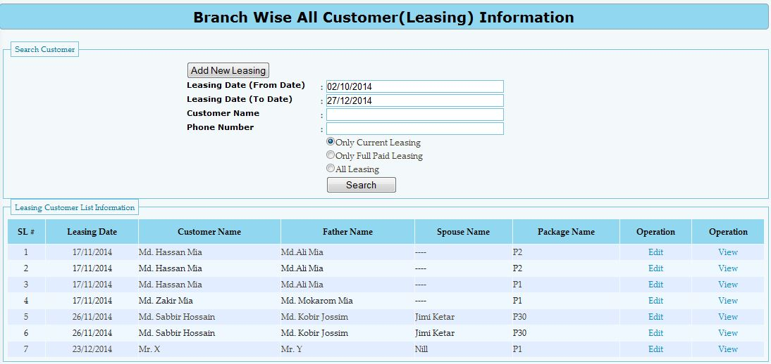

**All Leasing Information**

**Here in this form user can search leasing information of three types. They are current, full paid and all leasing**

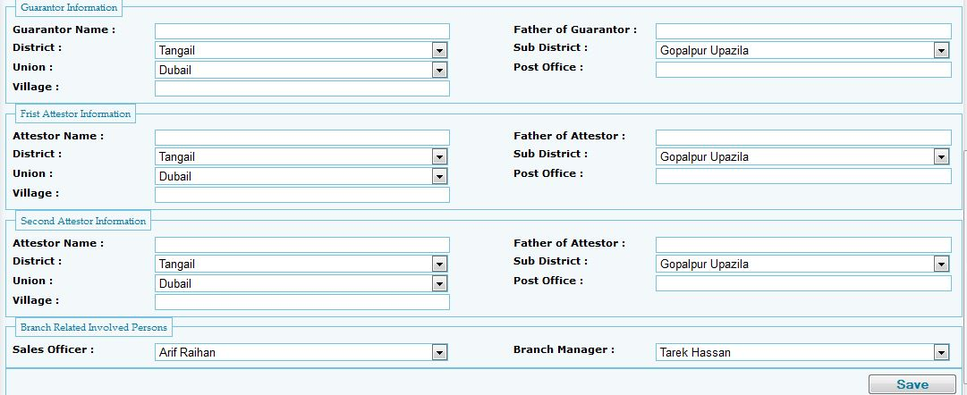

**New Leasing**

**In this form User need to enter information for new Leasing information entry.then need to press save button to save Leasing Info in the grid**

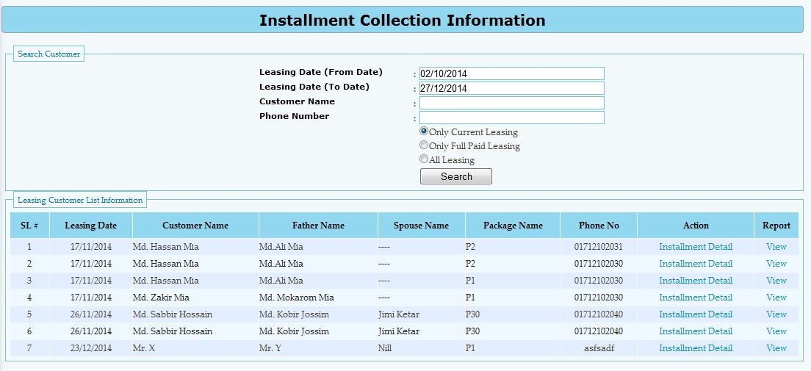

**Installment Collection**

**For installment collection user need to insert date range , customer name and Phone number to search about Installment collection information.**

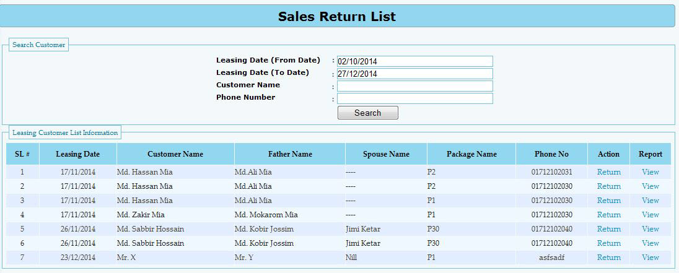

**Sales return**

**For sales return user need to insert date range, customer name and phone number for searching sales return information. If Information exist then it will be visible in the grid below.**

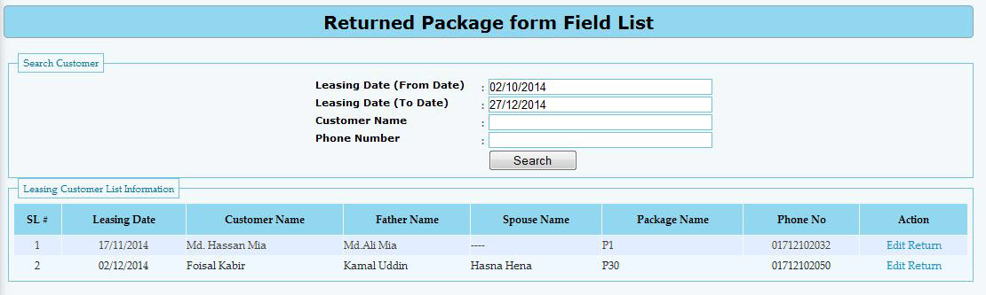

**Returned package from field**

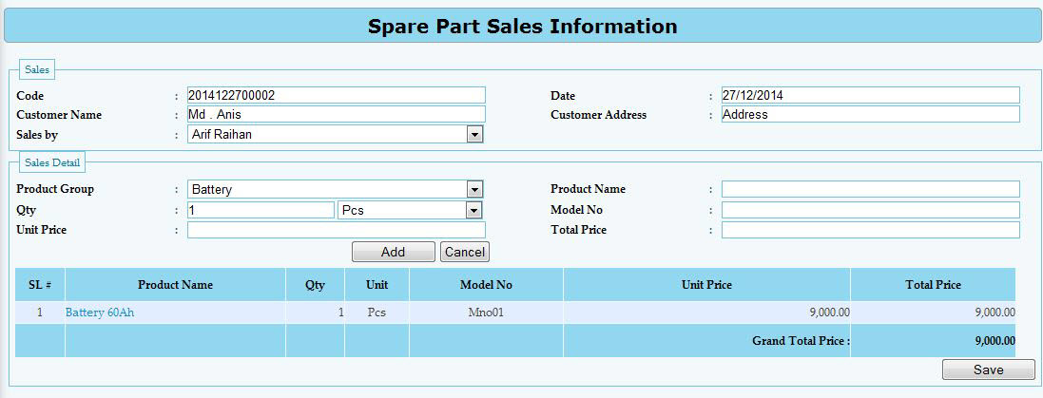

**Spare parts sales information**

* **Leasing information tables**

**Table name: Leasing**

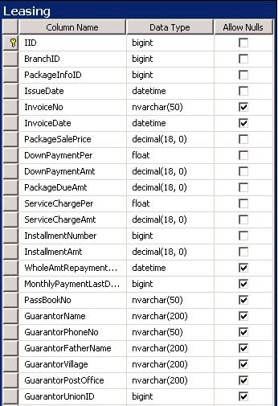

**Table name: Leasing description**

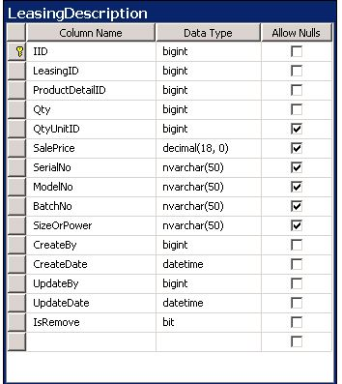

**Table name: Leasing Installment Collection**

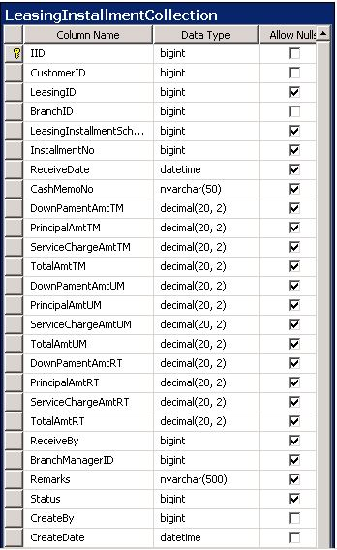

**Table name: Leasing installment schedule**

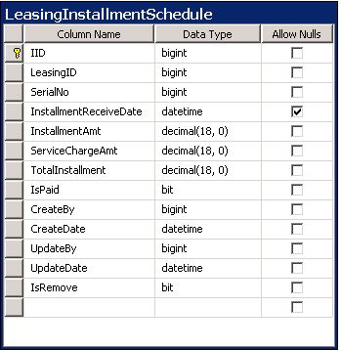

**Table name: Leasing Sales return**

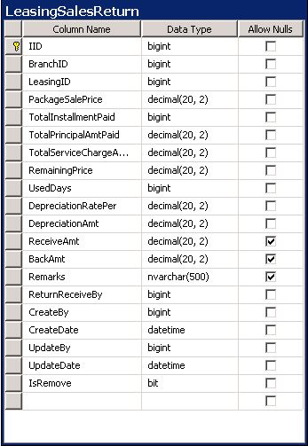

**Table name: Spare parts sales**

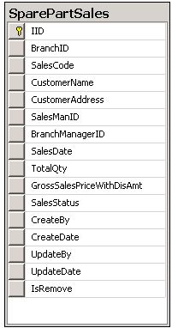

* **Report management UI:**

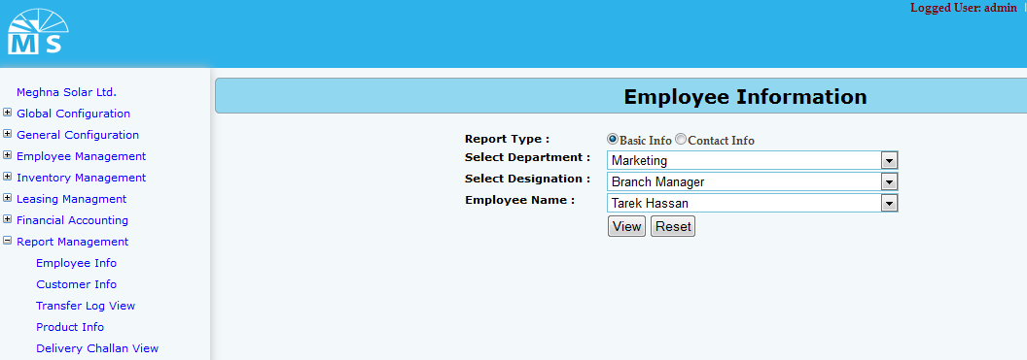

**Employee info Report (Basic info)**

**For emoployee info report there are two option. User can see Employee basic info or employee contact info. For basic info report user can directly click on view or may select department, designation and name for specific group or person’s report.**

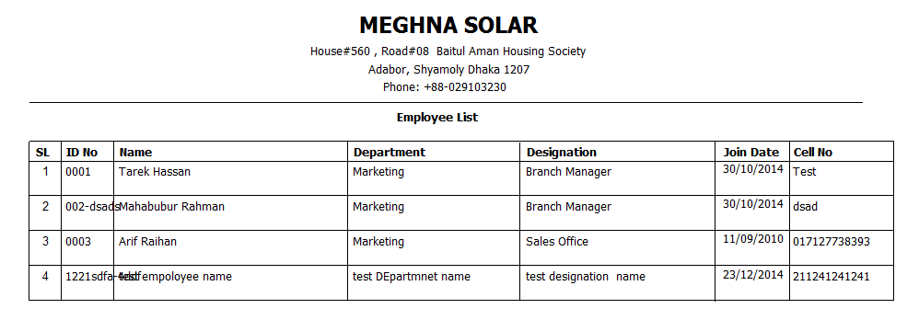

**Employee Basic Info Report**

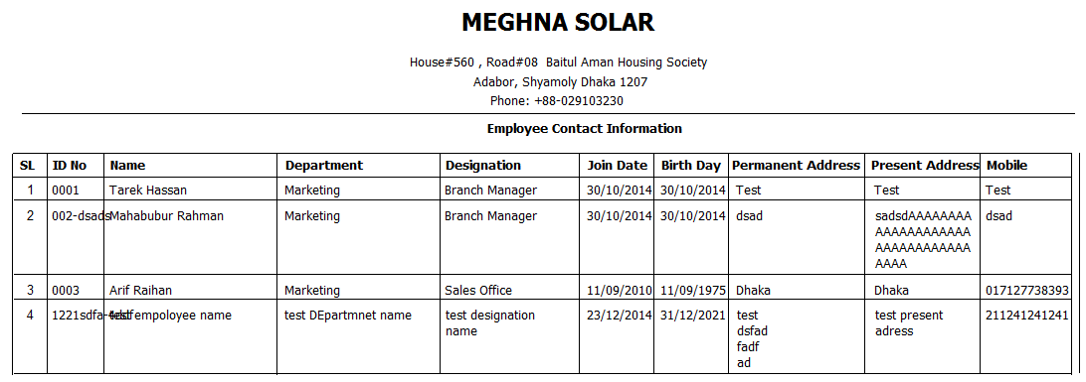

**Employee Contact Info report**

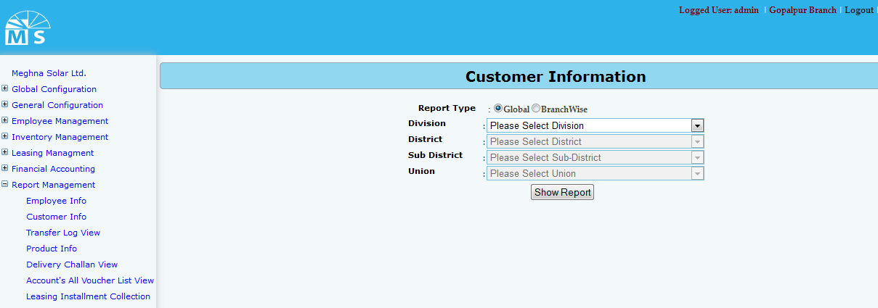

**Customer information report**

**For Customer information report there are two option. User can see Global info or Branch wise info. For Global info report user can directly click on Show report button or may select division, district, sub district and union for specific group or customer report.**

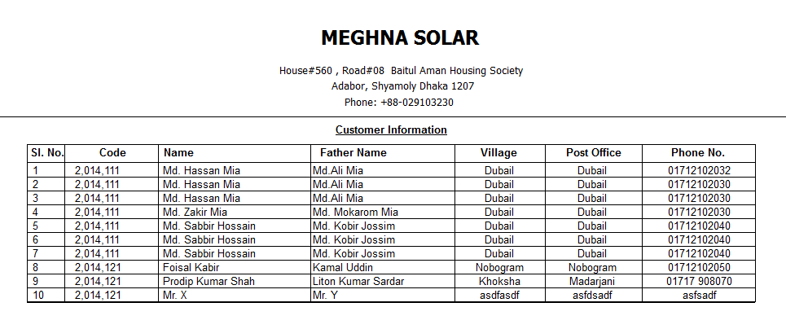

**Global information report**

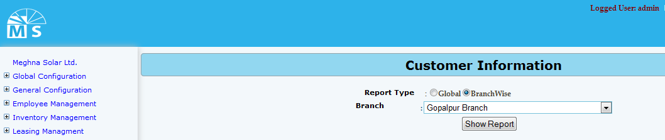

**Customer information report (branch wise)**

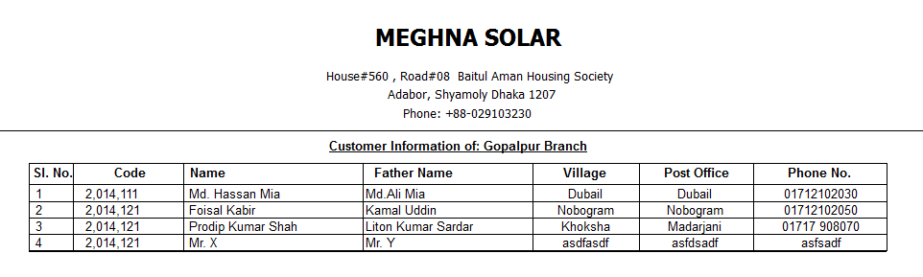

**Customer info report branch wise**

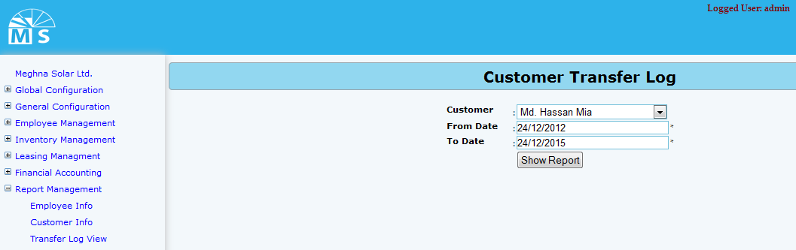

**Customer transfer log Report**

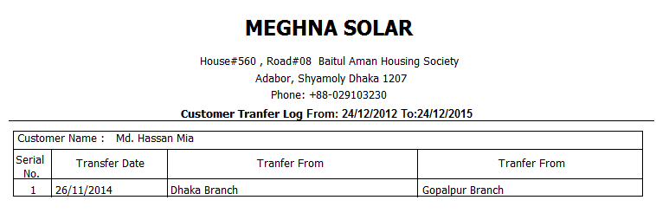

**Customer transfer log report**

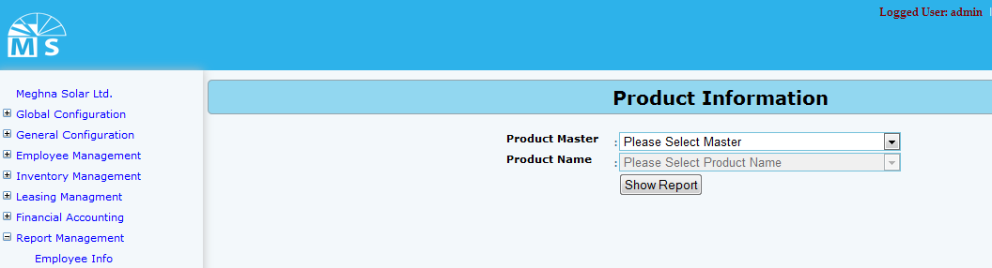

**Product information report page**

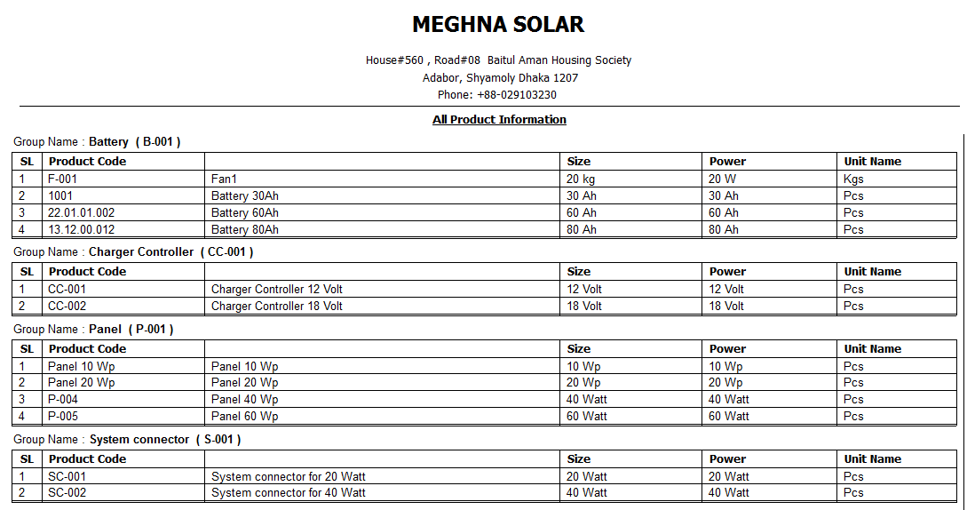

**Product information report**

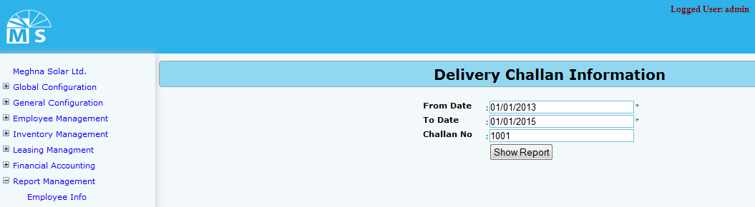

**Delivery Challan view report page**

**In Delivery Challan view report page user can view report by inserting from date and to date. Moreover for specific challan user can enter challan no and click show report button to see the report of that challan information.**

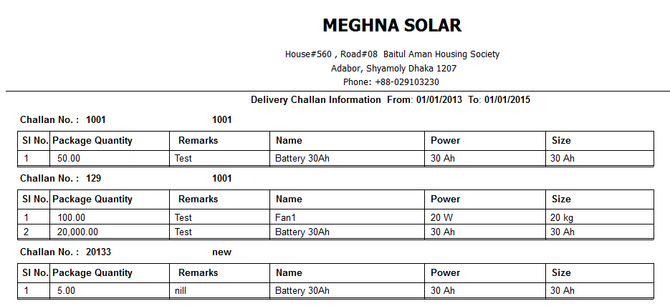

**Delivery challan view entry report**

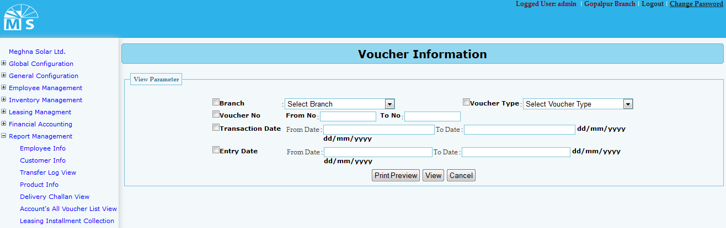

**Voucher information report page**

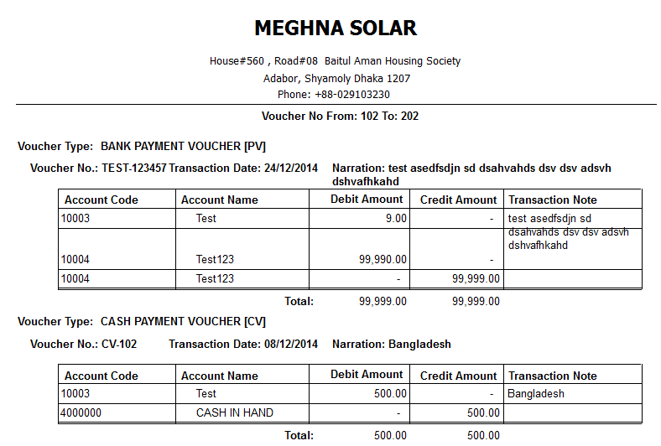

**Voucher information report**

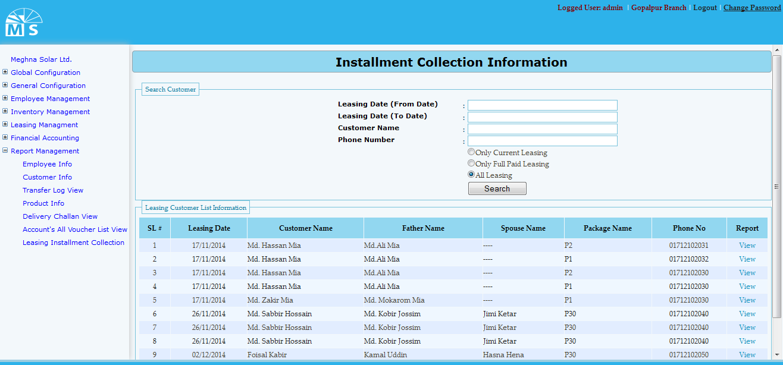

**Leasing installment collection report page**

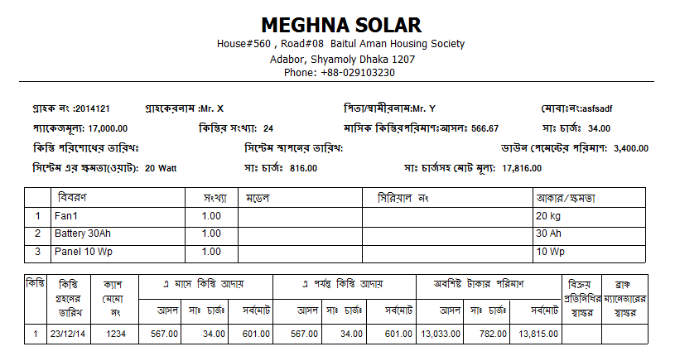

**Leasing installment collection report**

1. General Configuration

###### Requirements

|  |  |  |  |  |  |  |
| --- | --- | --- | --- | --- | --- | --- |
| MRD No | REQUIREMNT Identifier | Requirement Text / DATA | Acceptability | Limitations | Notes | Test case Identifier |
| 01 | 3.2.1 | Company Group Setup | All company group entry | Company group serial Number maintainer |  |  |
| 02 | 3.2.2 | Company Setup | Company Information setup |  |  |  |
| 03 | 3.2.3 | Factory Setup | Factory Information Setup | Factory code needed |  |  |
| 04 | 3.2.4 | Branch Setup | Branch Information Setup | Serial code maintains |  |  |
| 05 | 3.2.5 | Region Setup | Region Information Setup | Serial code maintains |  |  |
| 06 | 3.2.6 | Area Setup | Area Information Setup | Serial code maintains |  |  |

1. Employee Management

###### Requirements

|  |  |  |  |  |  |  |
| --- | --- | --- | --- | --- | --- | --- |
| MRD No | REQUIREMNT Identifier | Requirement Text / DATA | Acceptability | Limitations | Notes | Test case Identifier |
| 01 | 3.3.1 | Employee Information Setup | Employee Information, Education setup | Employee code maintains |  |  |
| 02 | 3.3.2 | Employee Transfer Tracking System | Employee Transfer log | Date Tracking |  |  |
|  |  |  |  |  |  |  |

1. Inventory Management

###### Requirements

|  |  |  |  |  |  |  |
| --- | --- | --- | --- | --- | --- | --- |
| MRD No | REQUIREMNT Identifier | Requirement Text / DATA | Acceptability | Limitations | Notes | Test case Identifier |
| 1 | 3.4.1 | Product Type Setup | Master Product type Setup | Code Maintains |  |  |
| 2 | 3.4.2 | Product Master Setup | Master Inventory Setup | Code Maintains |  |  |
| 3 | 3.4.3 | Product Detail setup | Product Details Information | No Duplicate Product Code |  |  |
| 4 | 3.4.4 | Package Specification | Package Specification Information setup | No Duplicate Pacakage Code |  |  |
| 5 | 3.4.5 | Inventory Head office | Factory to Head office inventory setup | Date and Qty |  |  |
| 6 | 3.4.6 | Delivery Challan | Deliver Package to other branch | Date and Qty |  |  |
| 7 | 3.4.7 | Inventory Stock Maintains | Maintaince Inventory | Date and Qty |  |  |
| 8 | 3.4.8 | Received Challan Branch wise | Received Inventory Challan | Date and Qty |  |  |

1. Leasing

###### Requirements

|  |  |  |  |  |  |  |
| --- | --- | --- | --- | --- | --- | --- |
| MRD No | REQUIREMNT Identifier | Requirement Text / DATA | Acceptability | Limitations | Notes | Test case Identifier |
| 01 | 3.5.1 | New Leasing Creation | Leasing information, Customer information, Service charge, down payment | Leasing Number tracking,  Payment condition |  |  |
| 02 | 3.5.1 | Installment Collection | Calculate Installment |  |  |  |
| 03 | 3.5.1 | Sales Return with depreciation | Track Sales return information |  |  |  |
| 04 | 3.5.1 | Spare part sales | Spare part sales Information |  |  |  |
| 05 | 3.5.1 | Integration to Accounting | Data insert to Accounting while installment collection |  |  |  |

1. Financial Accounting

###### Requirements

|  |  |  |  |  |  |  |
| --- | --- | --- | --- | --- | --- | --- |
| MRD No | REQUIREMNT Identifier | Requirement Text / DATA | Acceptability | Limitations | Notes | Test case Identifier |
| 1 | 3.6.1 | COA ,Voucher Transaction Entry From | Voucher code, Date |  |  |  |
| 2 | 3.6.2 | Ledger | Maintaince Control account Ledger |  |  |  |
| 3 | 3.6.3 | Trail balance, Balance Sheet | Calculate and View Trail balance |  |  |  |

1. Non-Functional Requirements
2. Performance Requirements

**PERFORMANCE REQUIREMENTS**

Performance should not be an issue because all of our server queries involve small pieces of data. Changing screens will require very little computation and thus will occur very quickly. Server updates should only take a few seconds as long as the phone can maintain a steady signal. The cost-division algorithms used by in application will be highly efficient, taking only a fraction of a second to compute.

|  |  |  |  |  |  |  |
| --- | --- | --- | --- | --- | --- | --- |
| MRD No | REQUIREMNT Identifier | Requirement Text / DATA | Acceptability | Limitations | Notes | Test case Identifier |
| 1 | 4.1.1 | All report loading from server response time should me limit | Avg. 10 to 15 Sec | For a big data need high band with |  |  |
| 2 | 4.1.2 | Account Transaction and Leasing Installment collection posting |  | need high band with |  |  |

1. Design Constraints

|  |  |  |  |  |  |  |
| --- | --- | --- | --- | --- | --- | --- |
| MRD No | REQUIREMNT Identifier | Requirement Text / DATA | Acceptability | Limitations | Notes | Test case Identifier |
| 1 | 4.2.1 | The client component of the system needs to be accessible on multiple platforms and from remote locations. | UAT | Technical |  |  |
| 2 | 4.2.2 | Dealing large transaction so each feature must be designed and implemented with efficiency in mind | UAT | Technical |  |  |

1. Safety Requirements

|  |  |  |  |  |  |  |
| --- | --- | --- | --- | --- | --- | --- |
| MRD No | REQUIREMNT Identifier | Requirement Text / DATA | Acceptability | Limitations | Notes | Test case Identifier |
| 1 | 4.3.1 | Daily Source code backup by TL | Source back up log |  |  |  |
| 2 | 4.3.2 | Production Data Base Server back ip by Meghna Solar | DB Back up log |  |  |  |
| 3 | 4.3.3 | Development server backup | DB Back up log |  |  |  |

1. Security Requirements

|  |  |  |  |  |  |  |
| --- | --- | --- | --- | --- | --- | --- |
| MRD No | REQUIREMNT Identifier | Requirement Text / DATA | Acceptability | Limitations | Notes | Test case Identifier |
| 1 | 4.4.1 | * The system shall only allow unauthorized users to access the login, lost password, and registration page. | Page Security |  |  |  |
| 2 | 4.4.2 | * The system shall require a login and password to gain access to the site. | Page Security |  |  |  |
| 3 | 4.4.3 | * The system will track Deleted and Updated data * The system wills permission to pages for individual access and individual operation of pages. | Meghna Solar Data Back up |  |  |  |

1. Software Quality Attributes

|  |  |  |  |  |  |  |
| --- | --- | --- | --- | --- | --- | --- |
| MRD No | REQUIREMNT Identifier | Requirement Text / DATA | Acceptability | Limitations | Notes | Test case Identifier |
| 1 | 4.5.1 | The graphical user interface of this Project is to be designed with usability as the first priority. | UAT |  |  |  |
| 2 | 4.5.2 | The application will be presented and organized in a manner that is both visually appealing and easy for the user to navigate | UAT |  |  |  |
| 3 | 4.5.3 | Change Management and No deployment with out Testing | Verification |  |  |  |
| 4 | 4.5.4 | To ensure reliability and correctness, there will be zero tolerance for errors in the algorithm that computes and splits expenses between group members. |  |  |  |  |

1. Other Requirements

|  |  |  |  |  |  |  |
| --- | --- | --- | --- | --- | --- | --- |
| MRD No | REQUIREMNT Identifier | Requirement Text / DATA | Acceptability | Limitations | Notes | Test case Identifier |
| 1 | 5.1 | User manual | TL’s Appraisal |  |  |  |
| 2 | 5.2 | Technical manual | TL’s Appraisal |  |  |  |
| 3 | 5.3 | Create in FQA | Verification |  |  |  |

This section defines any other requirements not covered elsewhere in the SRS. This might include database requirements, budget requirements, schedule requirements internationalization requirements, legal requirements and so on. Feel free to add any new sections that are pertinent to the project.

This section specifies those requirements that are concerned with possible loss, damage, or harm that could result from the use of the sub-system. It defines any safeguards or actions that must be taken, as well as actions that must be prevented. Refer to any external policies or regulations that state safety issues that affect the sub-system design or use. Define any safety certifications that must be satisfied.